**System**

**Specifications**

**Document of**

**GOGO COACH**

**Web Application**

-Prepared by

* Aline
* Shanthi Priya
* Bharti Madnani

**Abstract**

Any business that does not have a website is missing out on one of the most powerful marketing tools available to them. The main reason that it is important for businesses to have a website is how people are likely to find you. These days most people will go online and research products and companies before they make a purchase. For this reason of dependency on online, we develop a social platform to connect sports coaches with users interested in sports. Users can get various information about the coaches and he/she can access or enrol events organised by coaches by booking online. Usually, the client cannot get vast information about various coaches and their events in a single window. The client can also select the coaches based on their preferences. GoGo Coach is a social network that connects sports coaches with people who want to increase their physical activity or meet new people through sport. The observation is simple: too many people do not do sport or do little sport due to a lack of time, means or motivation. The objective of GoGo Coach is to address these issues by “uberizing" sports coaching and by making it easy for small incomes to be coached via group lessons.

Contents

1.Introduction to GoGo Coach **4**

2. Project objectives **4**

2.1 Introduction 4

2.2 Qualitative objectives 4

2.3 Quantitative objectives 5

3. Project presentation **5**

3.1User Journeys: 5

3.1.1Registration Journey: 5

3.1.2Complete User Journey: 5

3.1.3 Booking and Payment Journey: 6

4. System Analysis and Design **6**

4.1System Analysis of requirements 6

4.1.1Functional Requirements 6

4.1.2 Non-Functional Requirements 6

4.2System Design of requirements 7

4.2.1 System Context Diagram 7

4.2.2Package Diagram 7

4.2.3Use Case Diagram 8

5. Modules & Features **8**

5.1 Register Module 8

5.2 Login Module 8

5.3 Profile Module 8

5.4 Search Module 8

5.5 Events Module 8

5.6 Booking and Payment Module 8

6.Application Requirements **8**

6.1.1 User Interface 8

6.1.2 Application 9

# 1.Introduction to GoGo Coach

GoGo Coach was born from the shared passion for sport and well-being of its two founders: Aline, image consultant, and Julien, sports and fitness coach. Their meeting in Paris in 2017 at the 1st Sport and Well-being Fair marked the beginning of the GoGo Coach adventure. Their mutual vision of democratizing sport and getting people to move pushed them to join forces in 2018 and to create their project. After a year of thinking about their concept, they are now launching their project with the aim of presenting it at this year’s Sport and Well-being Fair.

# 2. Project objectives

## 2.1 Introduction

GoGo Coach is a social network that connects sports coaches with people who want to increase their physical activity or meet new people through sport. The observation is simple: too many people do not do sport or do-little sport due to a lack of time, means or motivation. The objective of GoGo Coach is to address these issues by “uberizing" sports coaching and by making it easy for small incomes to be coached via group lessons.

## 2.2 Qualitative objectives

The goal of the application is to connect sports coaches with users. The first objective is to allow coaches to present their services and philosophy through the creation of their own page. Active users will be able to bookmark the pages of coaches near their home or work and to follow the availability and events proposed by these coaches. The second objective is to democratize physical activity by offering group lessons at a decreasing rate according to the number of participants. Clients will also be able to locate at a glance the available coaches in their vicinity via an interactive map system.

## 2.3 Quantitative objectives

Enrolment objectives: 5000 registered in the first year, with 1000 coaches (mainly in Paris, Lyon, Marseille and Bordeaux, before a roll-out throughout France).Frequency of use: daily to follow the coaches' news, 1 to several times a week to book a session.

# 3. Project presentation

The project is a web application, which can also be consulted on mobile phones and tablets. Access to the site and registration are free: GoGo Coach makes money by taking a percentage of all bookings made through the application. Reservation and payment are made via the application. The objective is to release an operational v1 to be presented during the Sport and Well-being Fair.

## 3.1User Journeys:

### 3.1.1Registration Journey:

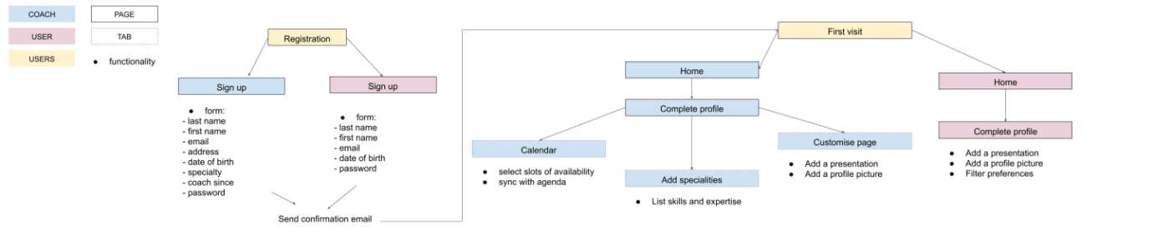

### 3.1.2Complete User Journey:

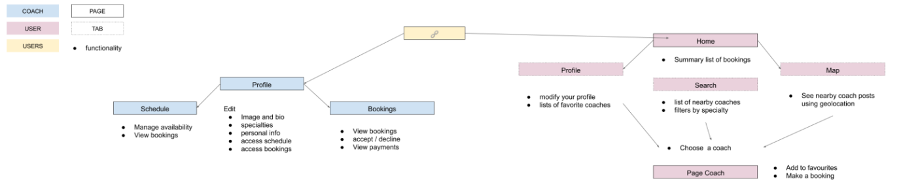

### 3.1.3 Booking and Payment Journey:

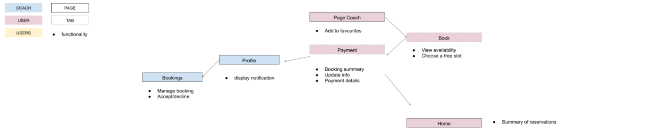

# 

# 4. System Analysis and Design

Users are divided into two categories: we will call here

●coach​ a sports professional who offers their services on the platform,

●client​ an individual seeking physical activity,

●users​ will designate the two categories

## 4.1System Analysis of requirements

## 

## 4.1.1Functional Requirements

* User account for client and coaches
* creation of "coach" pages
* possibility to add content to the pages
* users can favourite “coach” pages
* interactive map – geo-location-based availability of coach post filters
* Search for nearby coaches
* search/filter by speciality of coach
* creation of schedule
* booking of events
* push notifications
* payment system for events

## 4.1.2 Non-Functional Requirements

* The system should only be available to registered users.
* Creation of events should be sync with the objective of the system.
* Enrolment objectives: 5000 registered in the first year, with 1000 coaches (mainly in Paris, Lyon, Marseille and Bordeaux, before a roll-out throughout France).
* Frequency of use: daily to follow the coaches' news, 1 to several times a week to book a session.

## 

## 4.2System Design of requirements

## 4.2.1 System Context Diagram

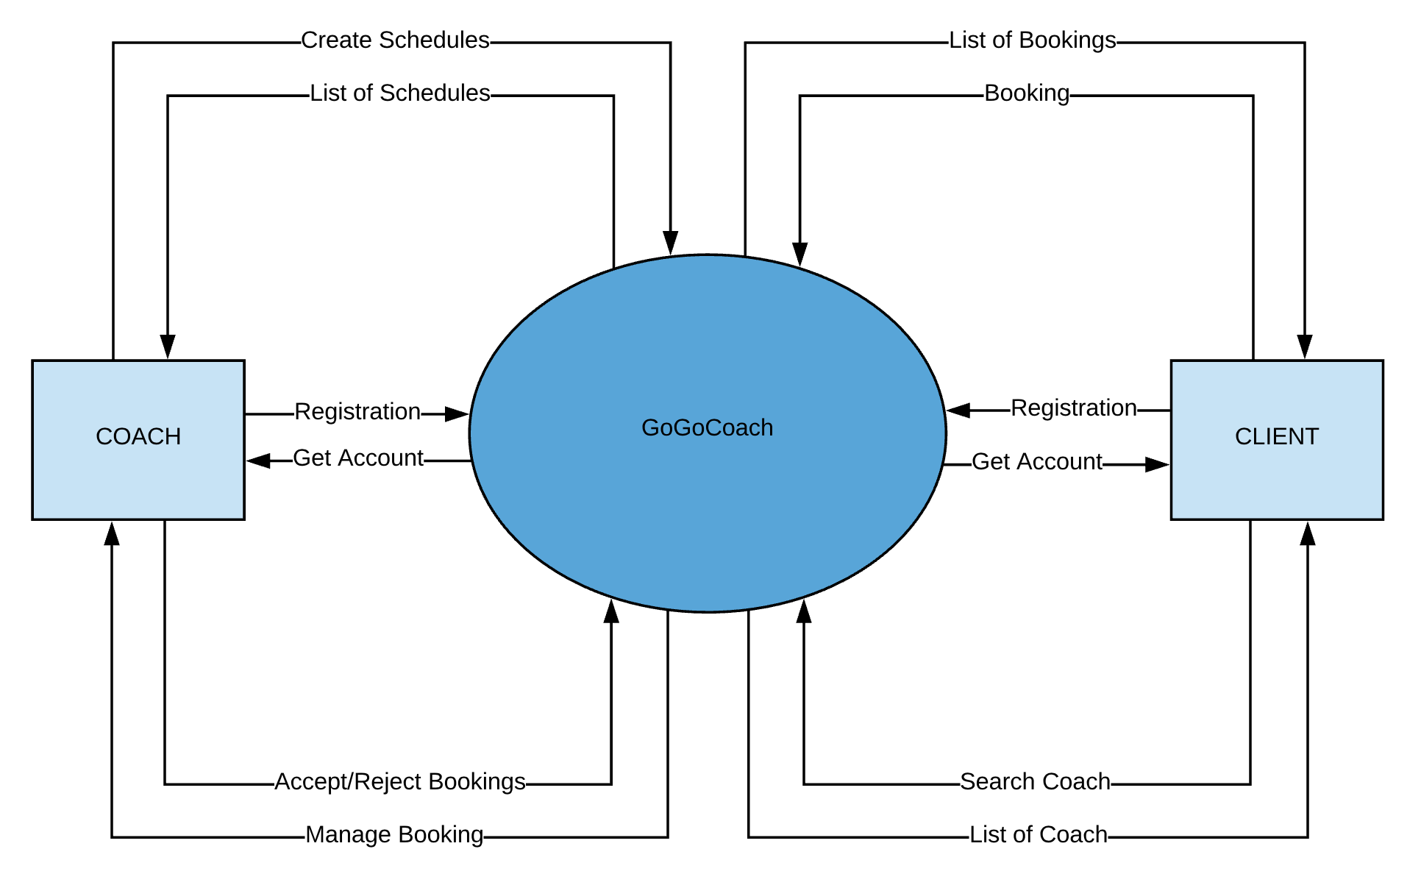

## 4.2.2Package Diagram

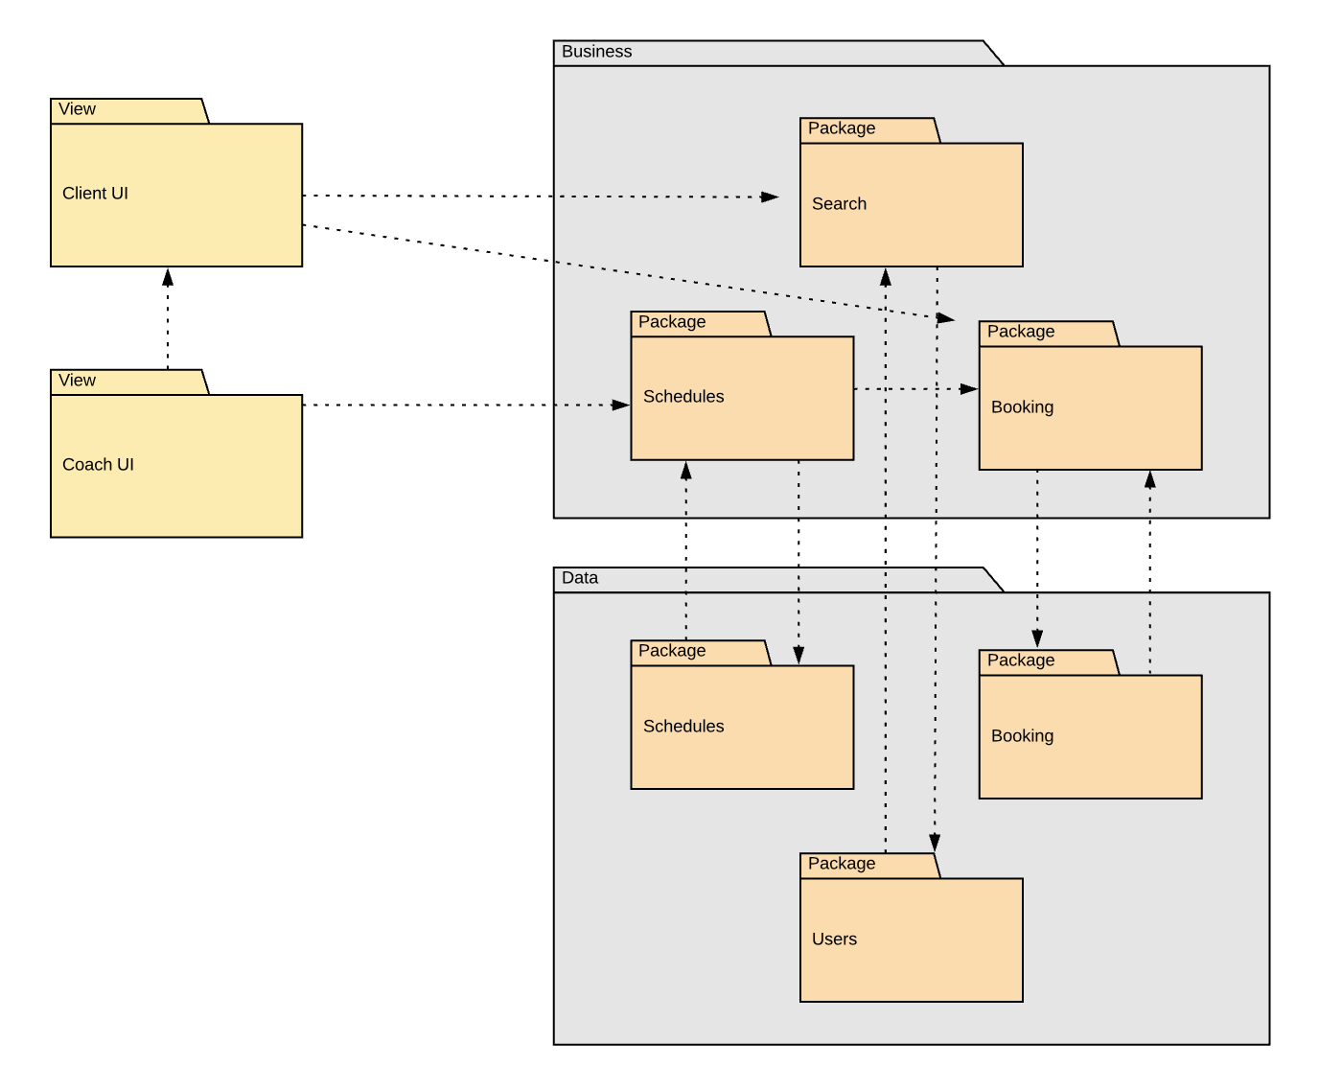

## 4.2.3Use Case Diagram

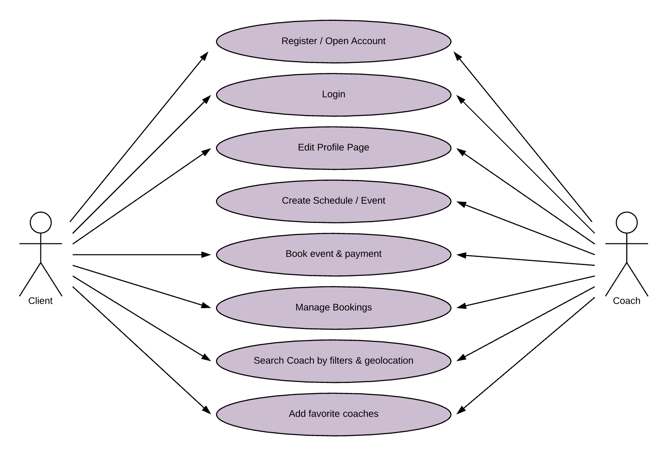

## 4.2.4 Database relationship Diagram

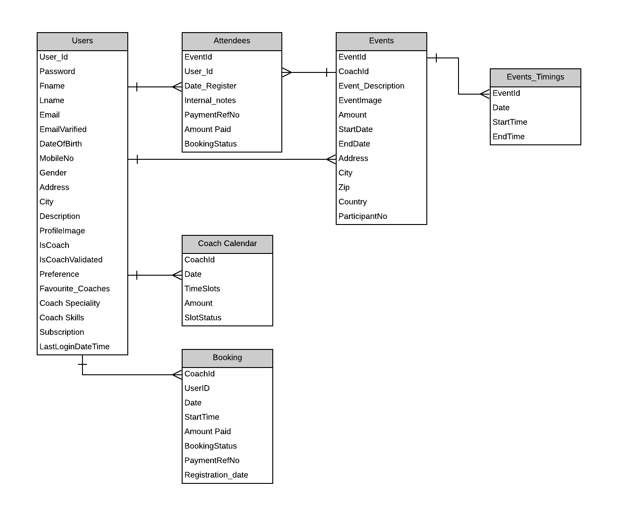

# 5. Modules & Features

## 5.1 Register Module

### Description:

Users register all their details to create an account in the system. Registered users can be either a sports coach or client to access the system.

* The client creates an account by providing first name, surname, email, date of birth and password.
* Sports coach creates an account by providing the first name, last name, email, address, date of birth, speciality, coach since and password.
* After validating the form data, the user generates a token and generate the email link and embed the token in the verification link. Send verification link through email to the user email id provided in the signup form.
* When the user triggers the verification link from the email, decode the token and verify it. If it is valid, user data is created in the database.

### Sequence Diagrams

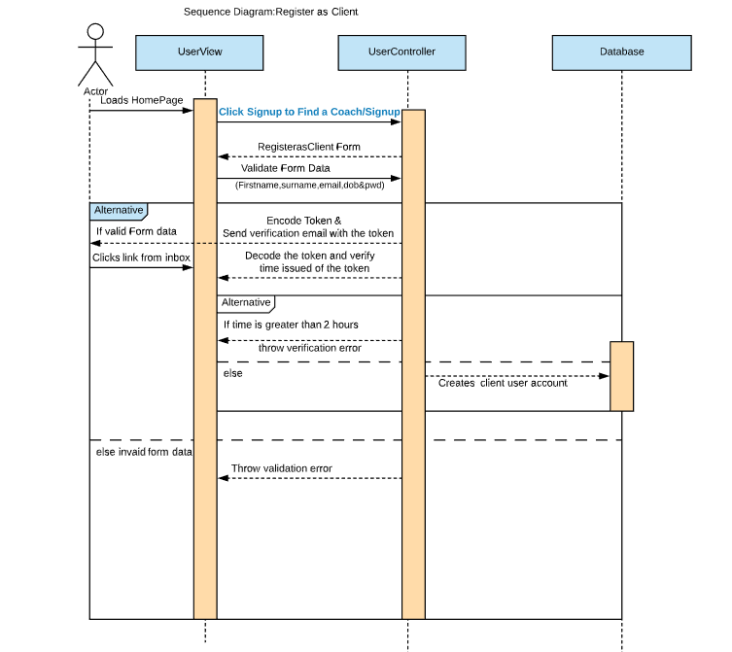

### Mockup Screens:

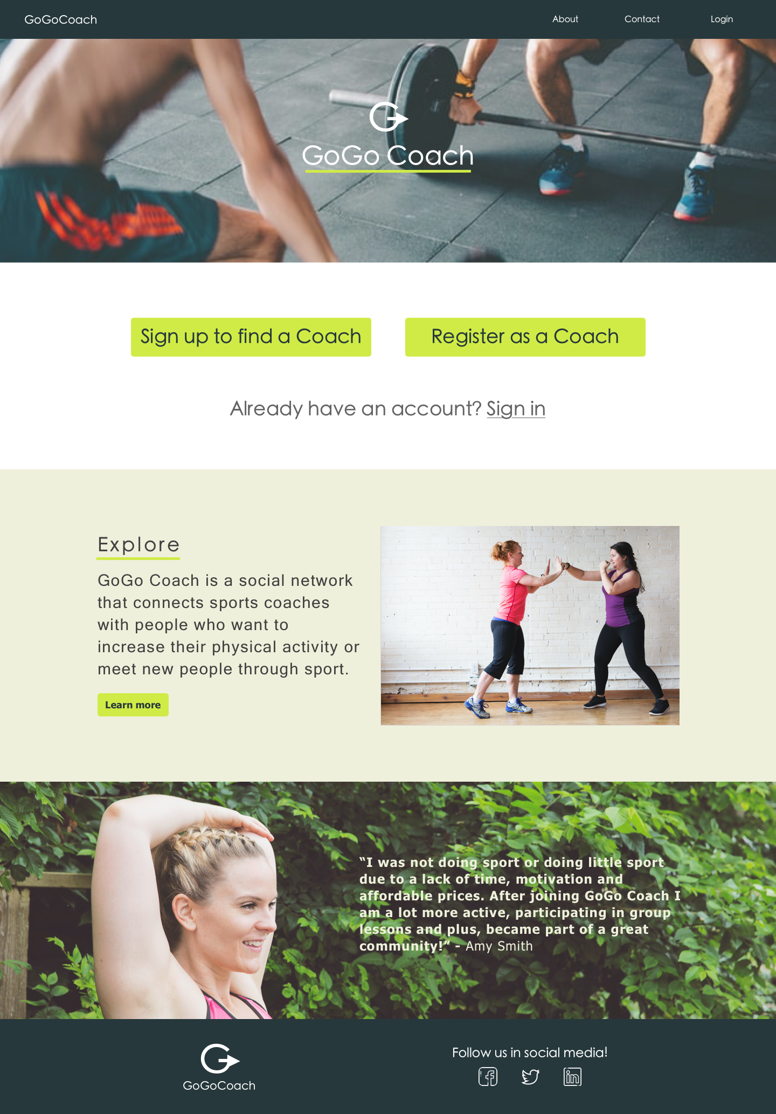

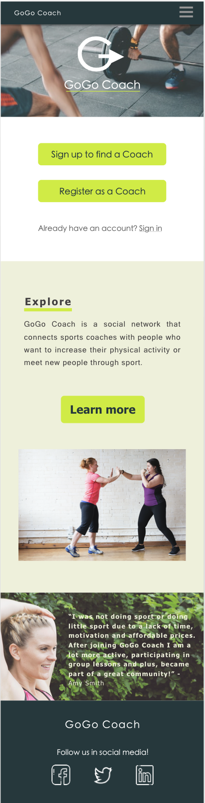

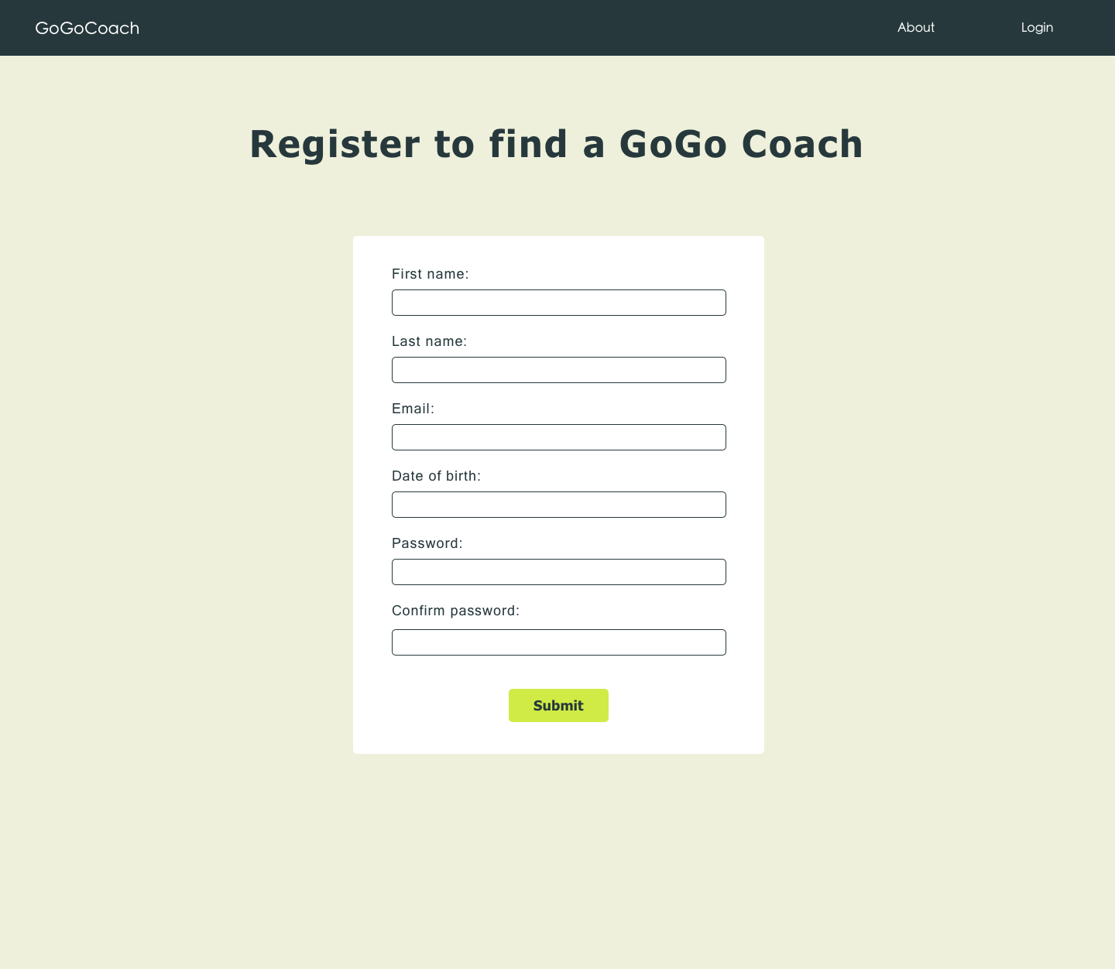

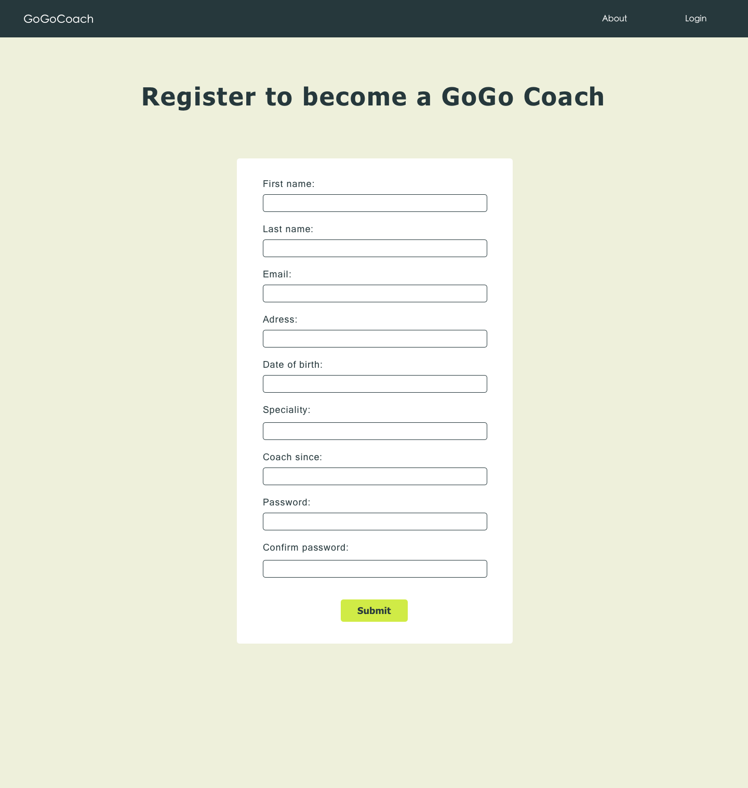

## 5.2 Login Module

### Description:

After creating an account, the user logs in to the system by providing username and password. An error message will be displayed for an invalid user. If valid user, the user is redirected to the home page with a welcome message to complete the profile. Users can be either a sports coach or client to access the system. After successful login,

* Client’s homepage will have a My profile, Find a coach and logout navigation links.
* A sports coach will have a My profile, Bookings, Schedule, Find a coach and Logout navigation links.
* Sports coaches can also access the system as a client.
* Push notification subscription confirmed and saved in the system

### Sequence Diagrams:

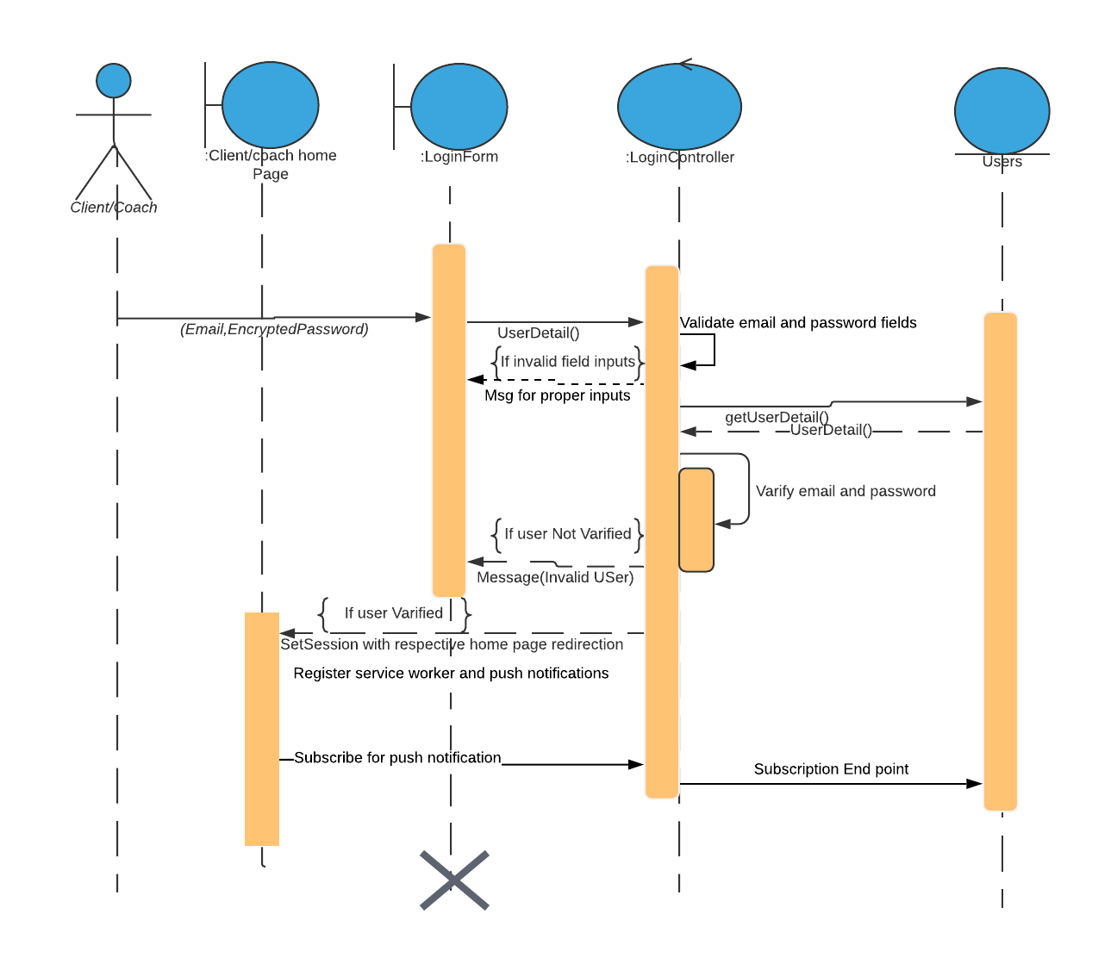

### Mockup Screens:

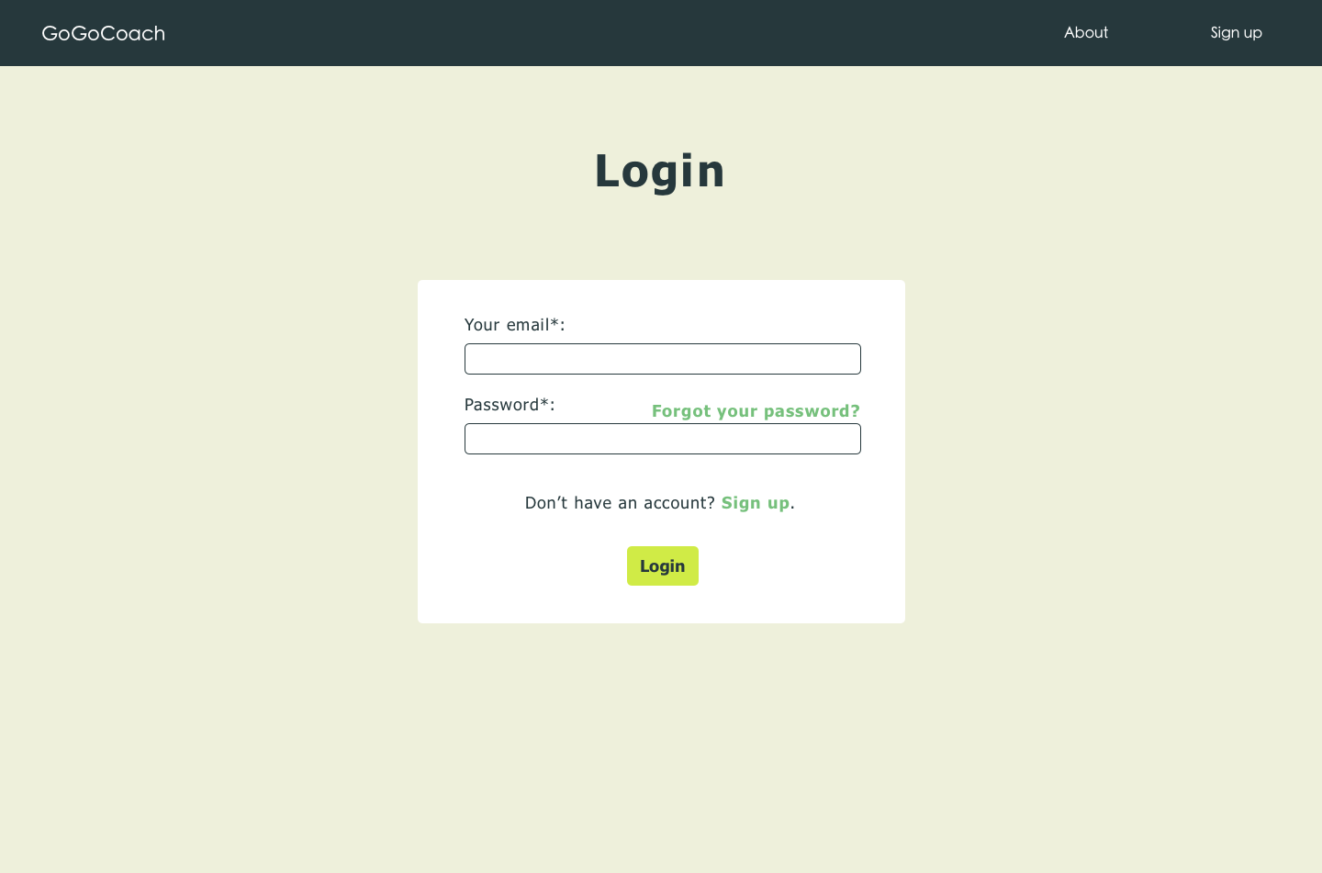

## 5.3 Profile and Search Module

### Description of Profile Module:

Valid Users can edit their profile and update their details.

* Clients edit their profile by adding presentations and preferences and updates the profile picture.
* Sports coach can edit their profile by updating their skills and expertise, presentation details and profile picture.

### Description of Search Module:

Users can search for a coach based on location and their speciality. Users can also filter coaches based on geographic location.

* Clients search for a sports coach based on their speciality or location.Also, filter the coach based on geographic location
* Sports coach can also act as a client and search for other coaches and their events.

### 

### Sequence Diagrams of Search and Profile:

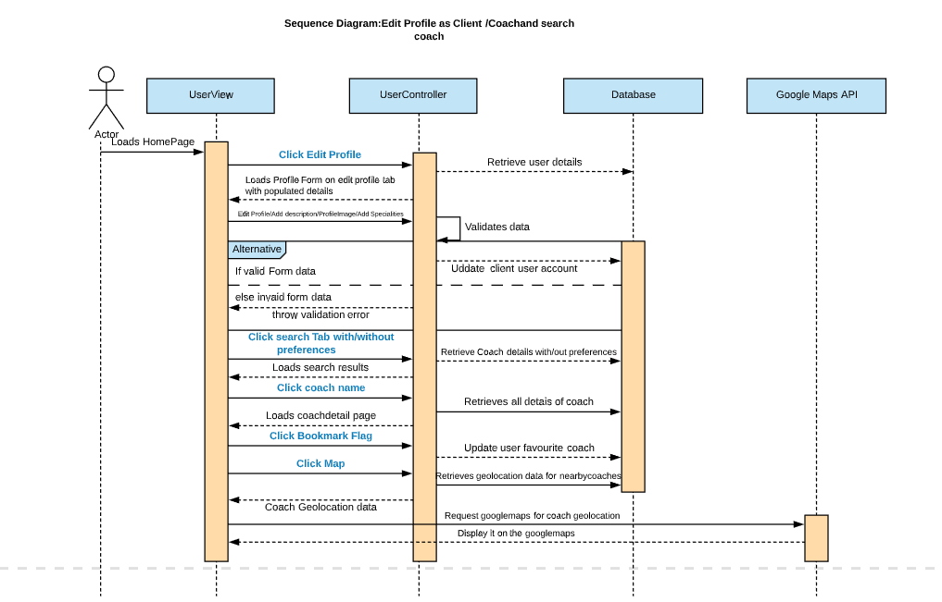

### Mockup Screens:

Welcome message

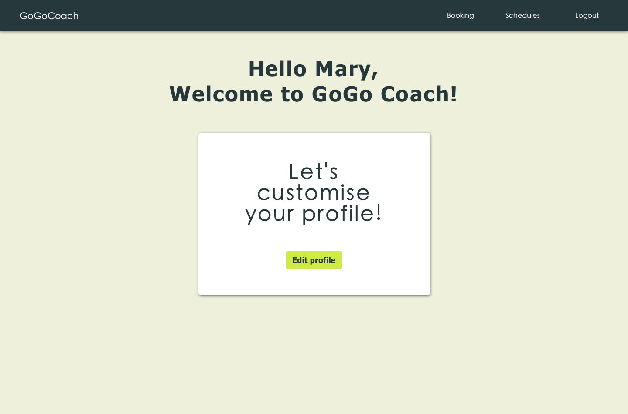

First time Coach Profile

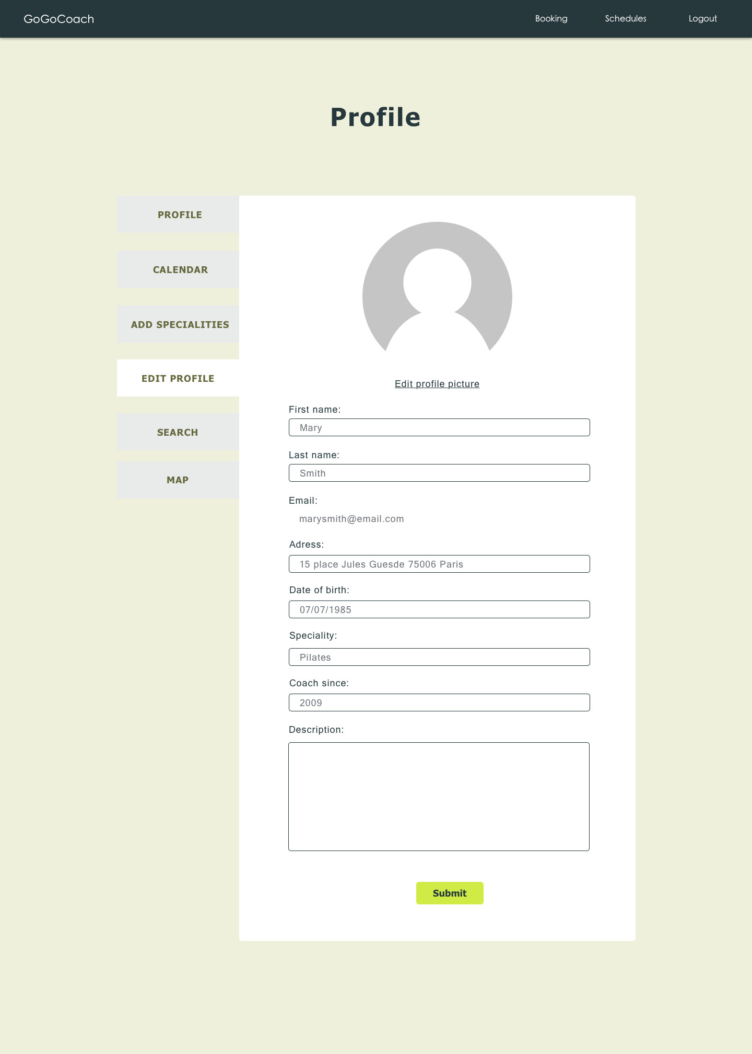

Profile page before updating

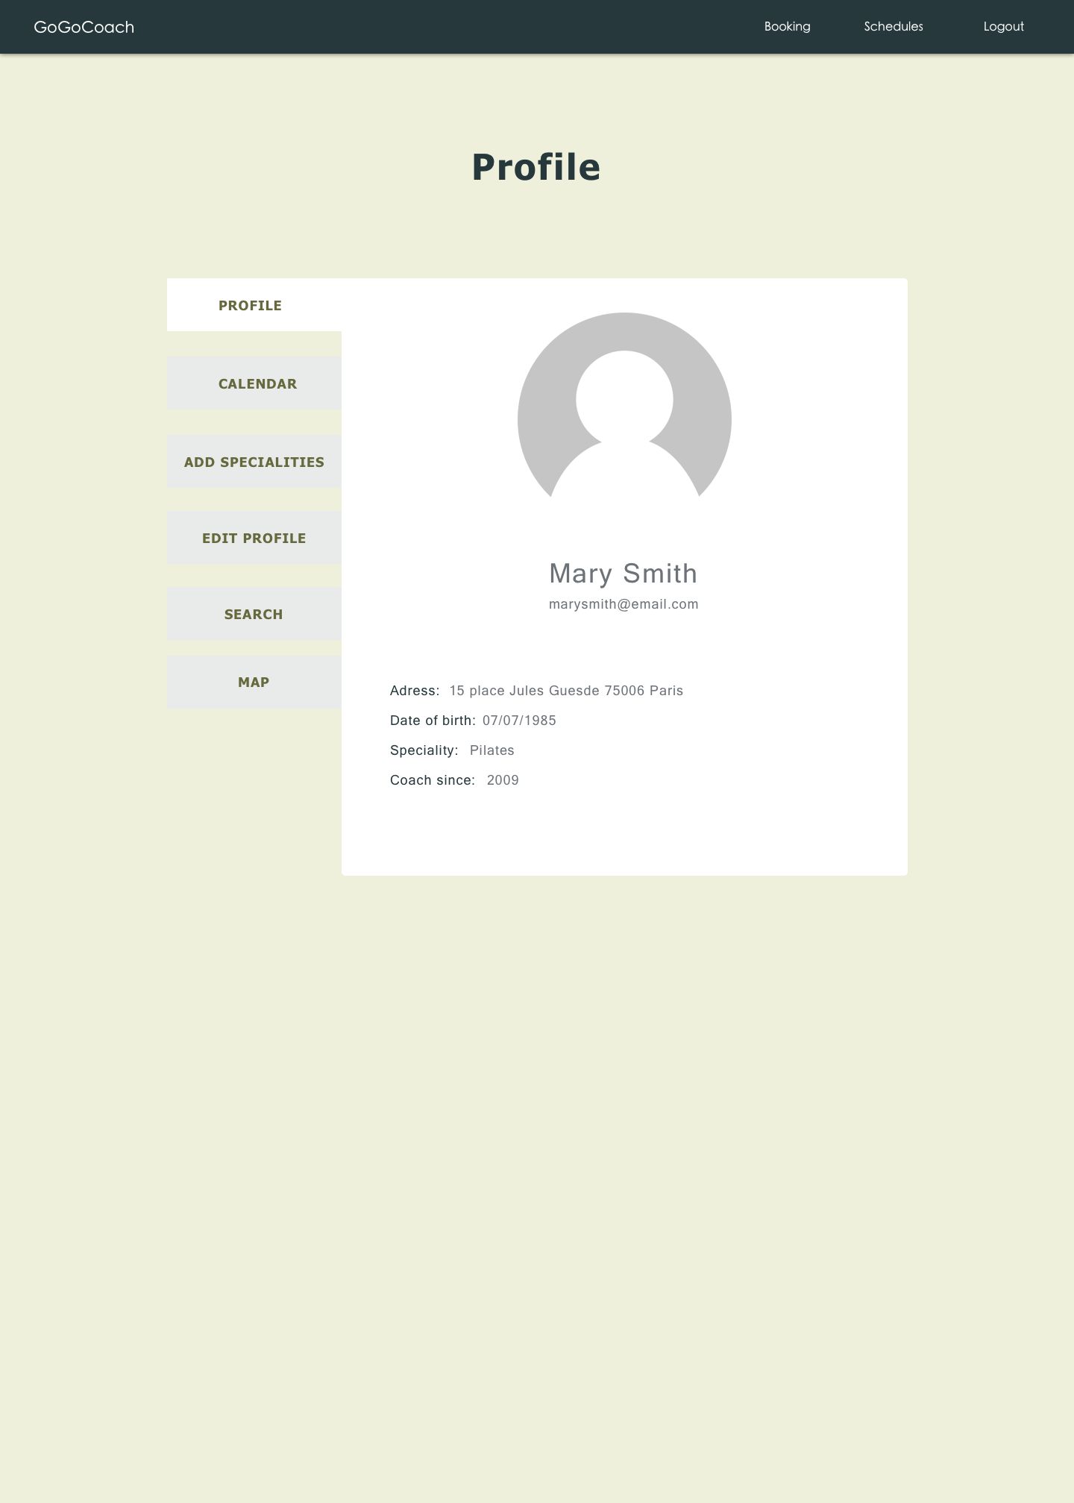

Profile page after updating

## 

First Time Client profile page

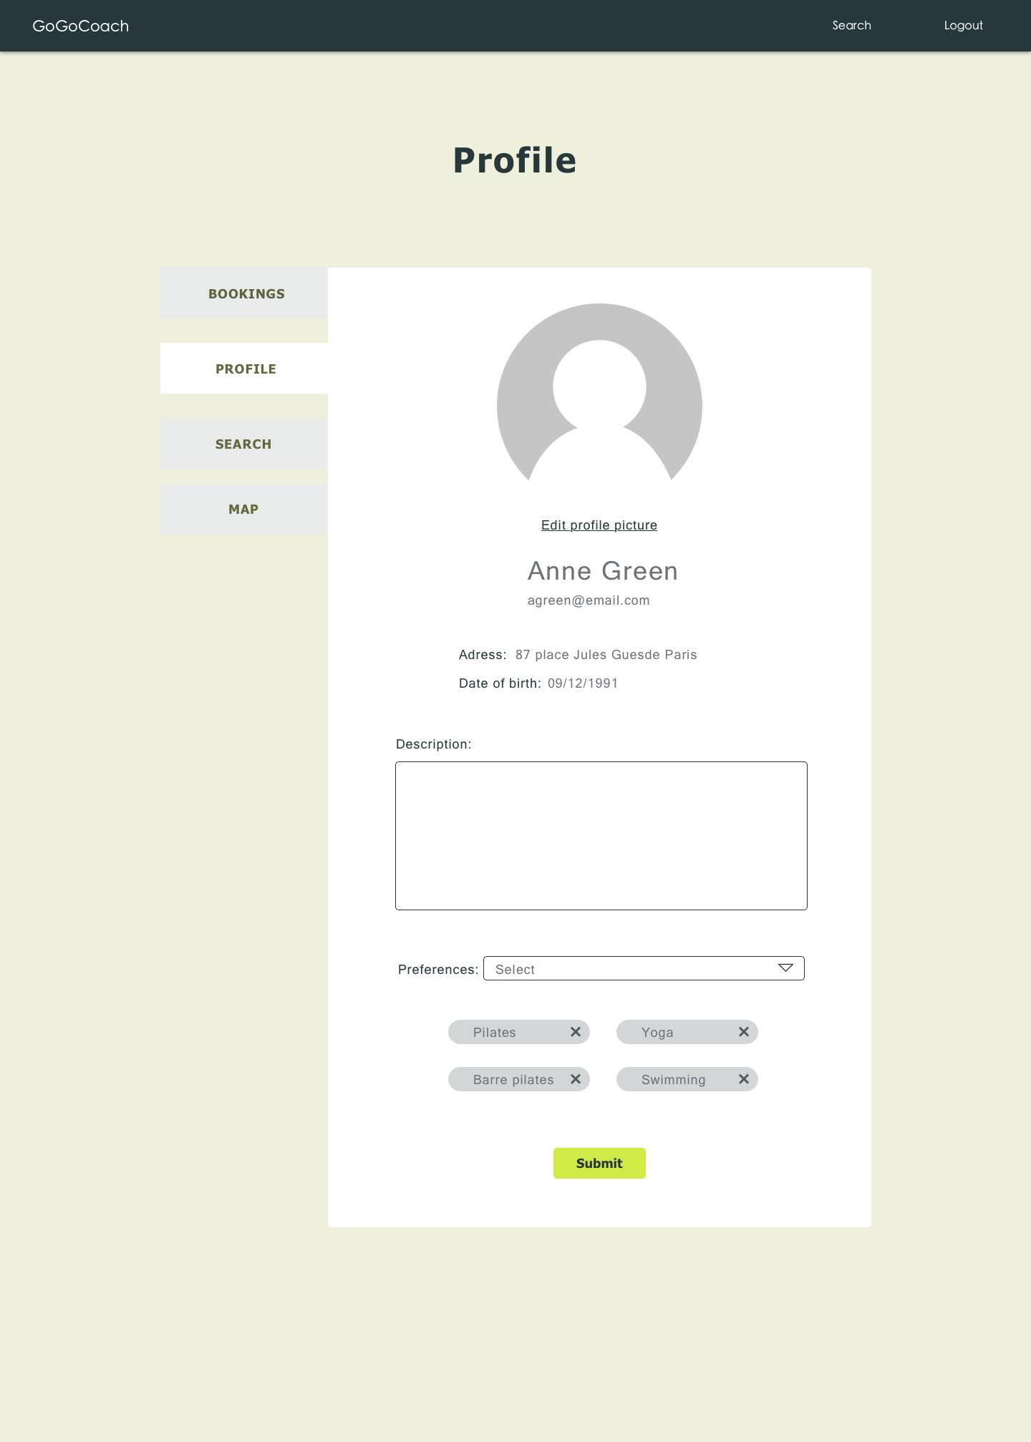

After updating client profile

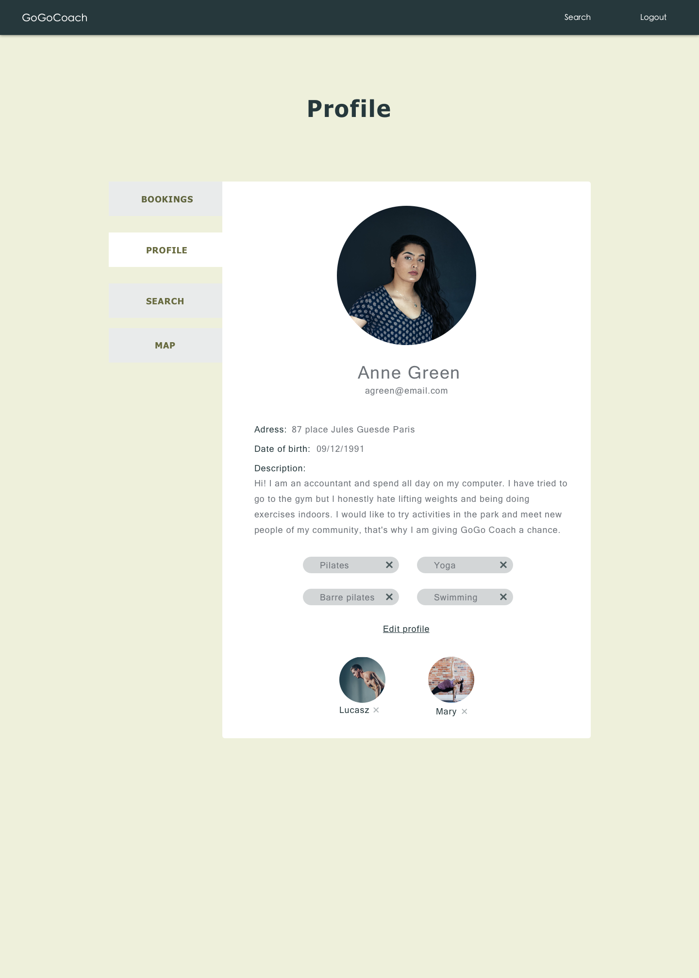

Booking summary

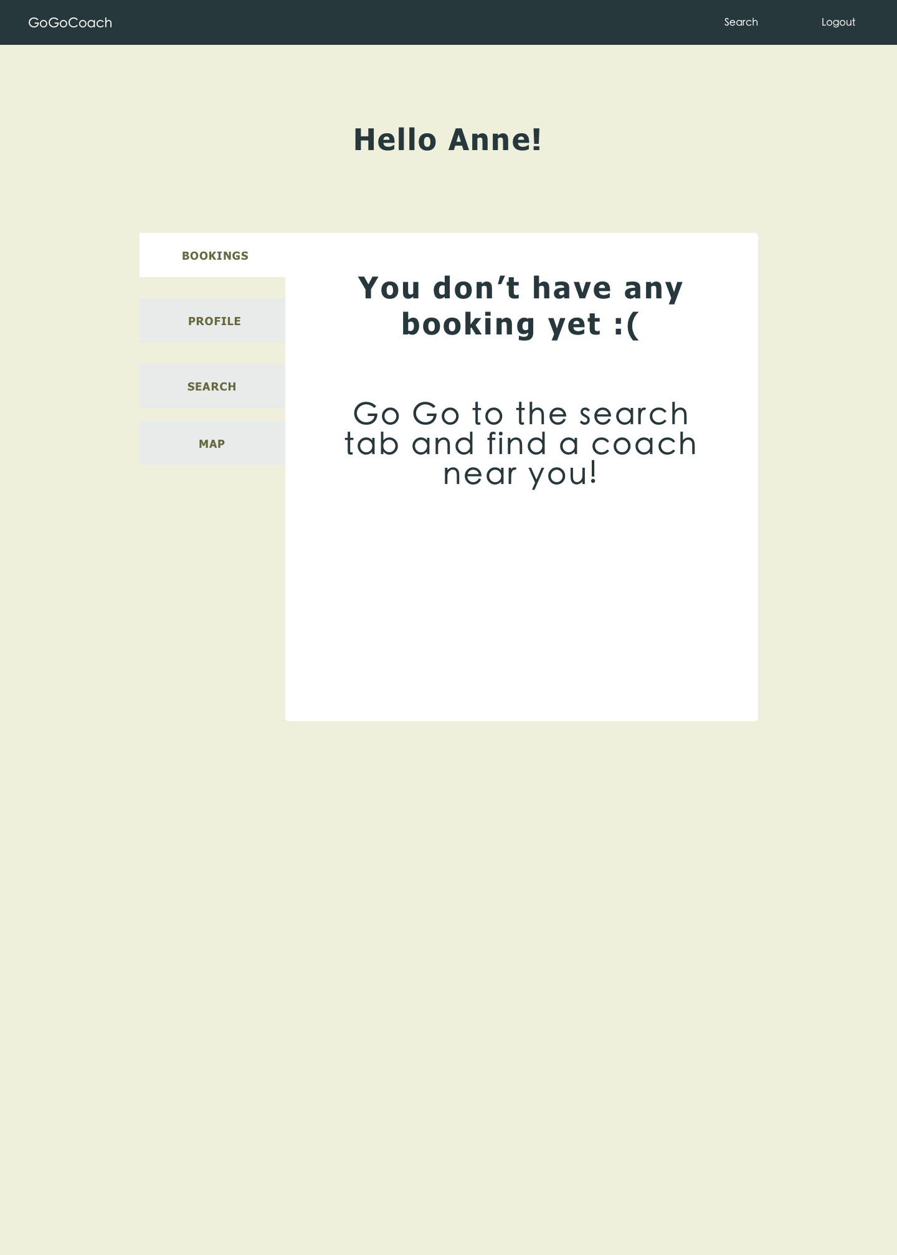

Search coach based on preferences

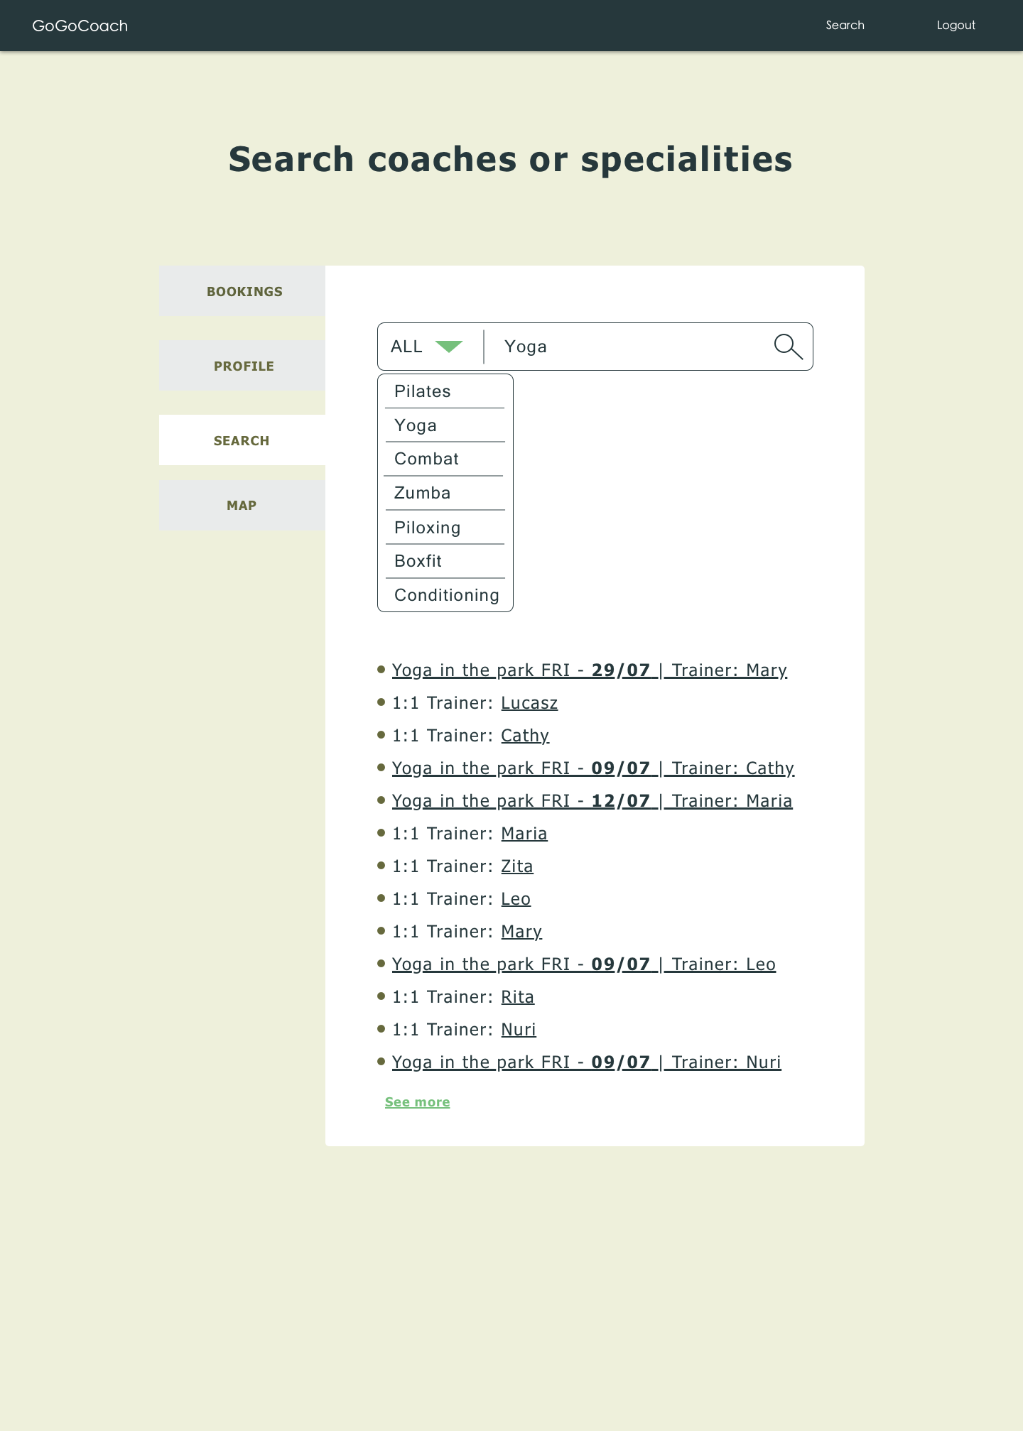

Search by geolocation

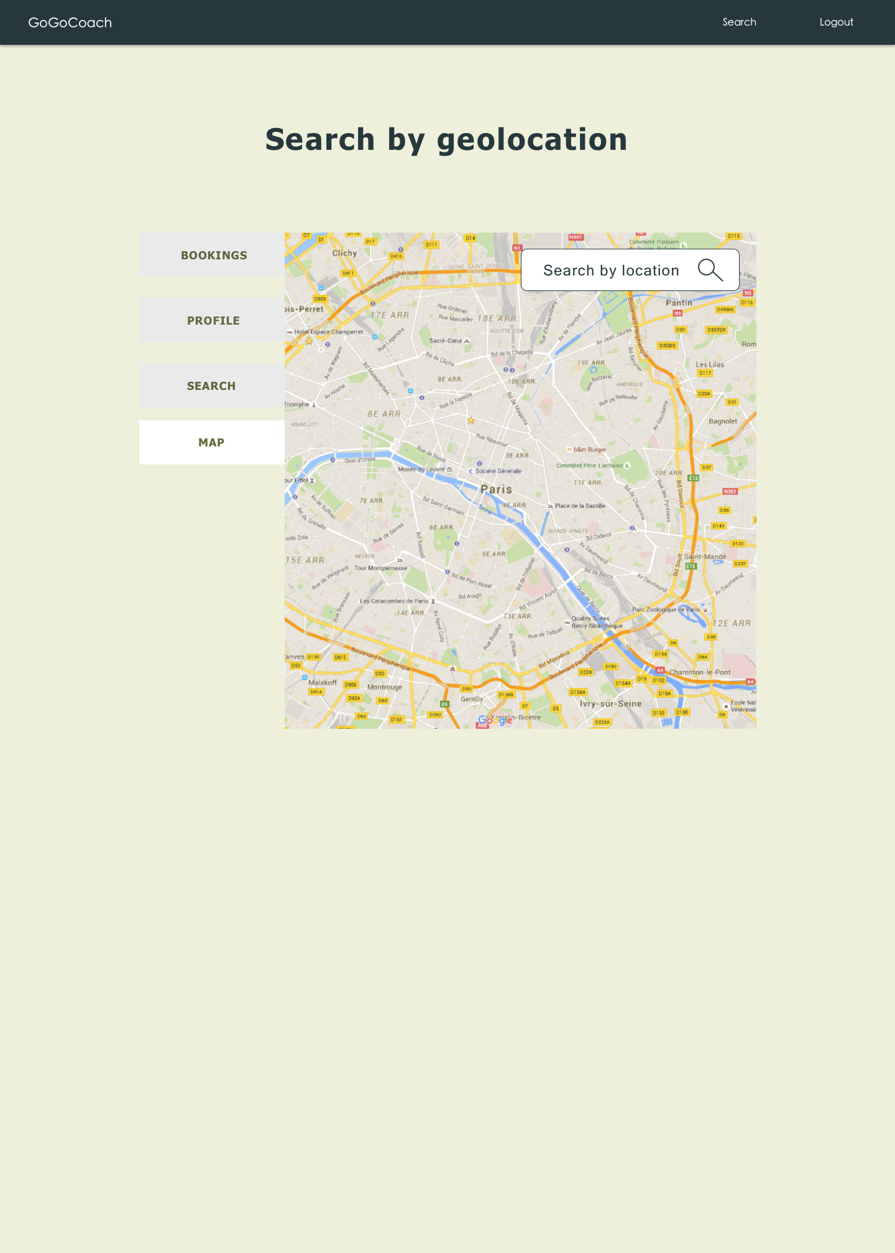

Mobile View of edit client profile page

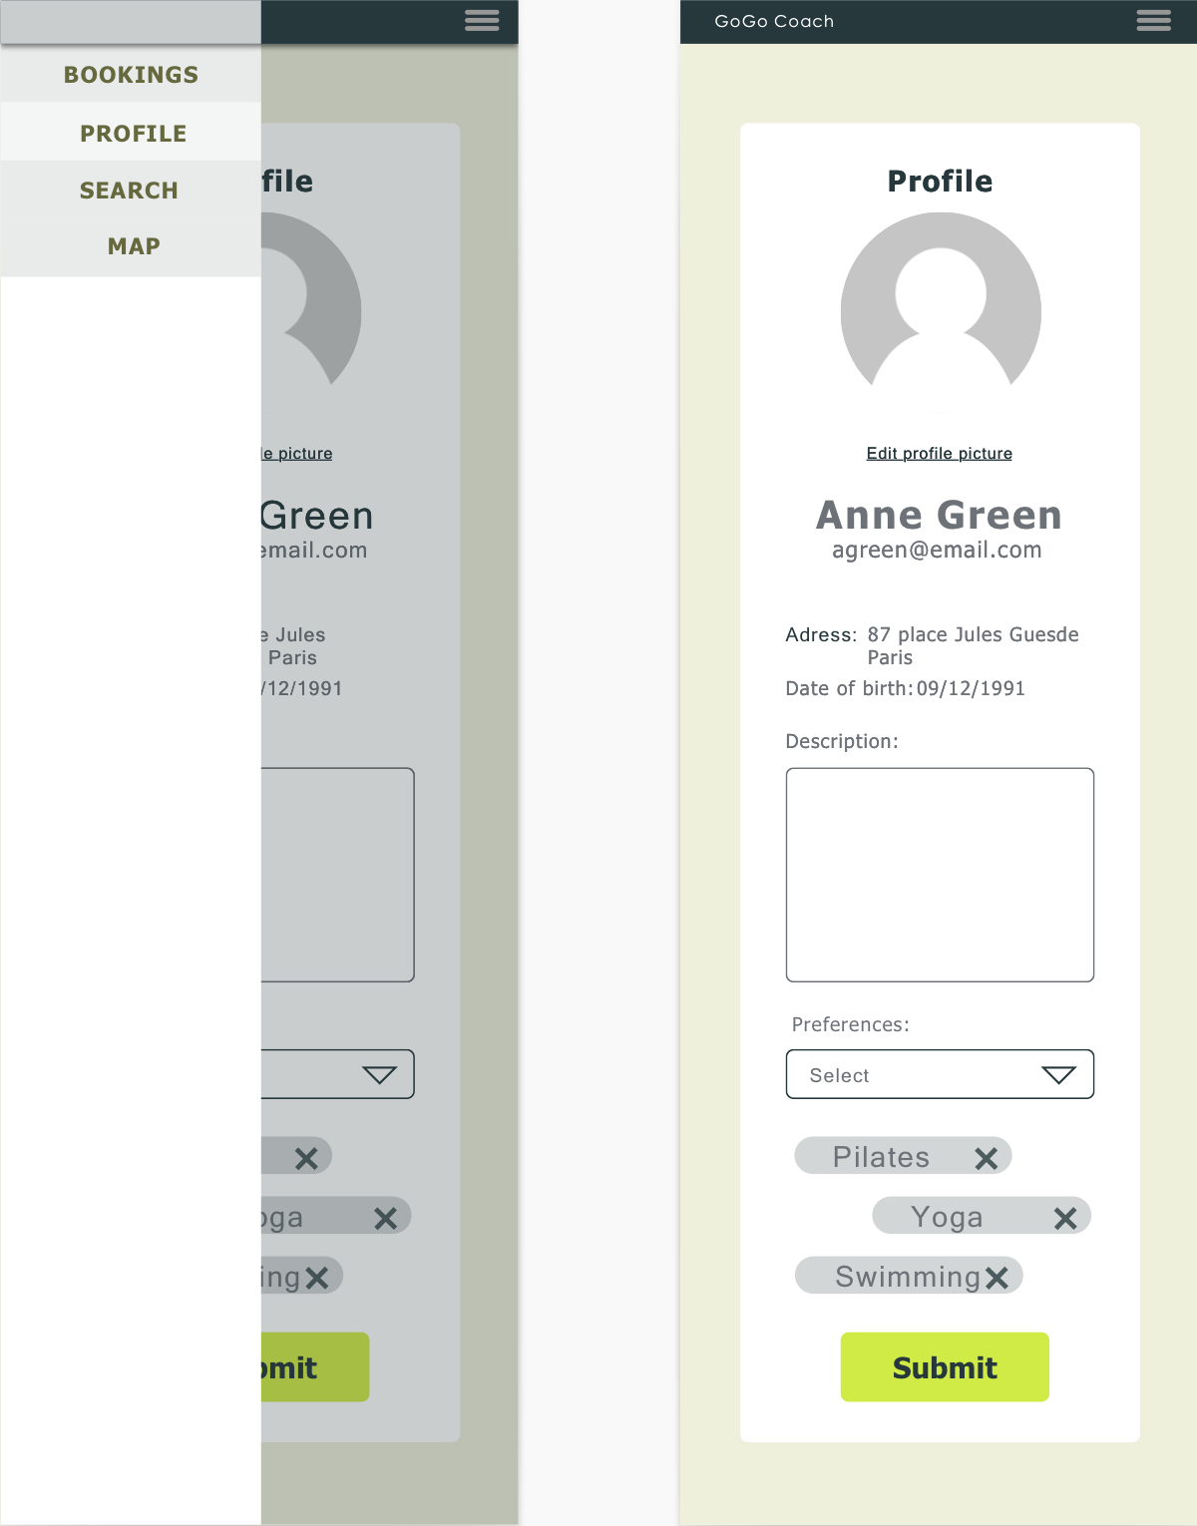

## 5.4 Events Module

Users can schedule an event by selecting available slots from the calendar and display the schedules in the agenda

* Clients don't have access to this module.
* Sports coach can create an event by selecting from the available slots and post it to the agenda.

### Sequence Diagrams:

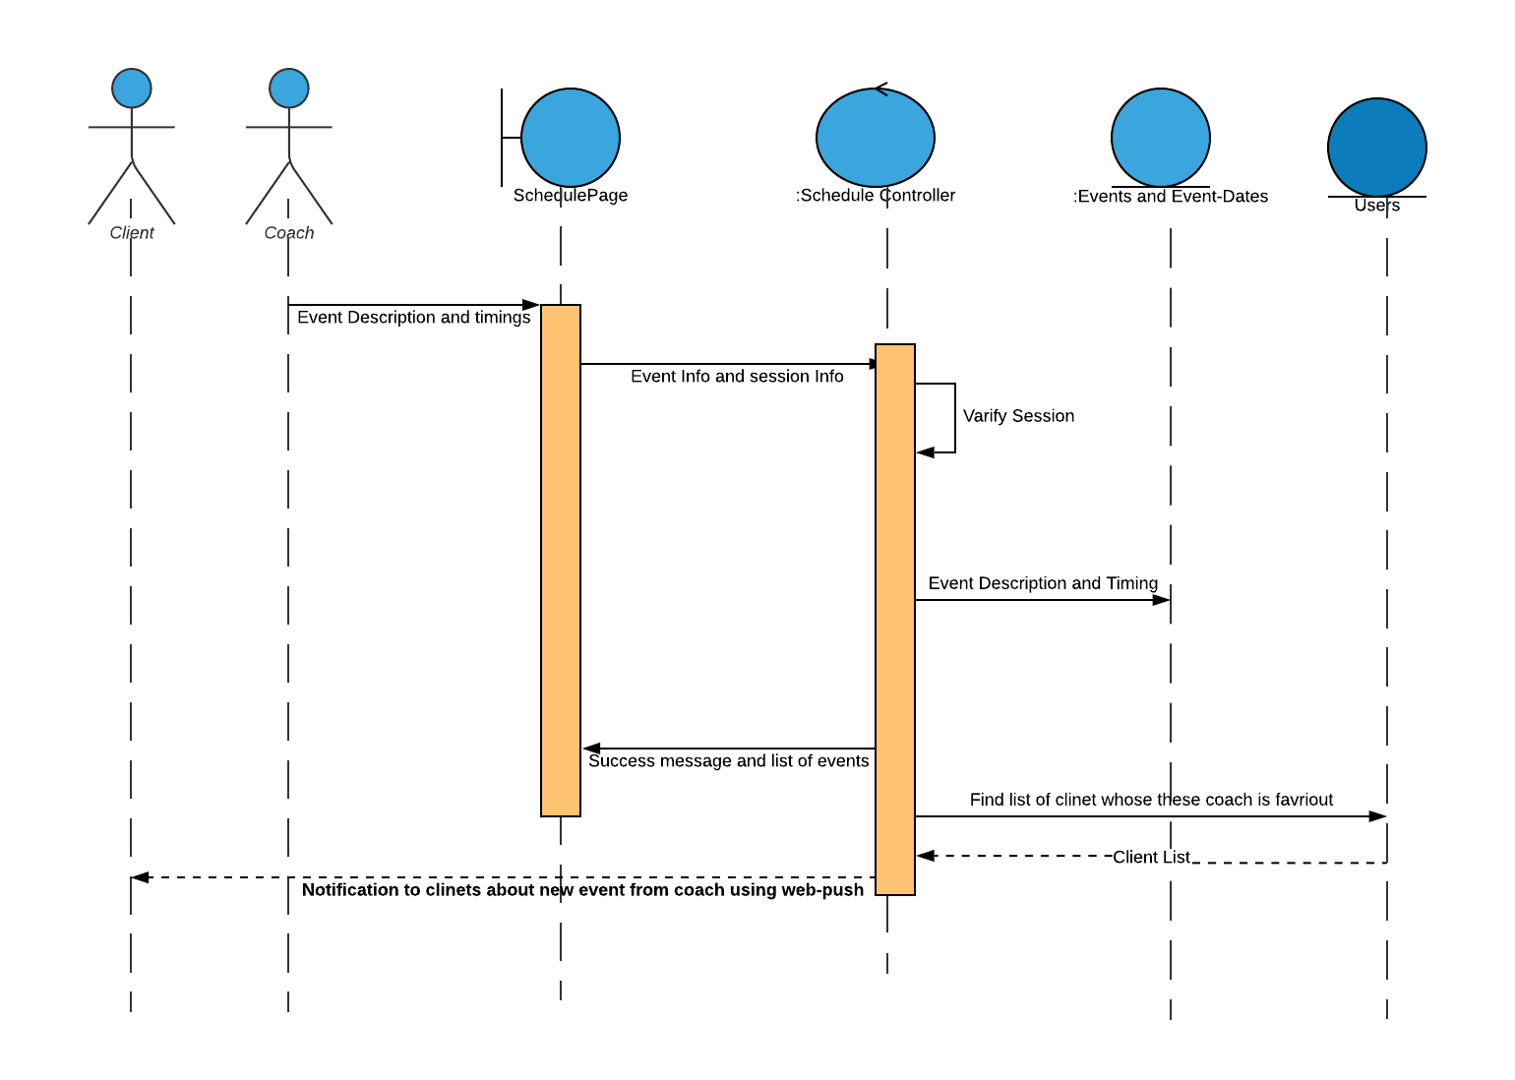

### Mock up Screens:

Calendar

## 

Create one day Event

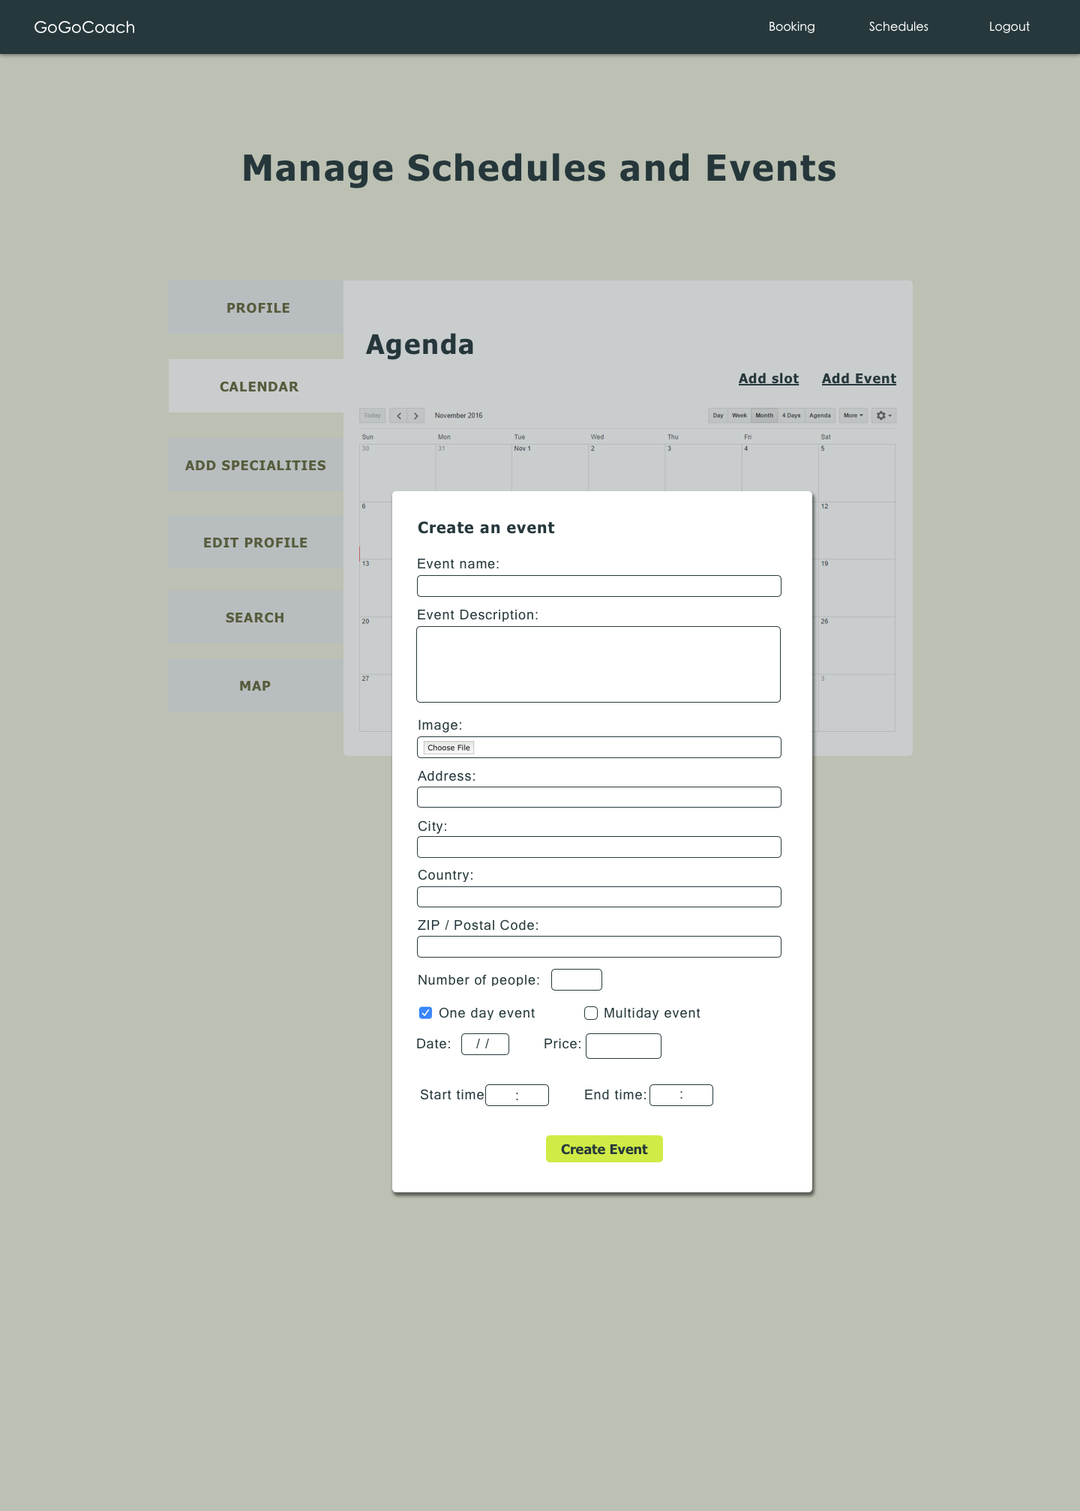

Create a multi day Event

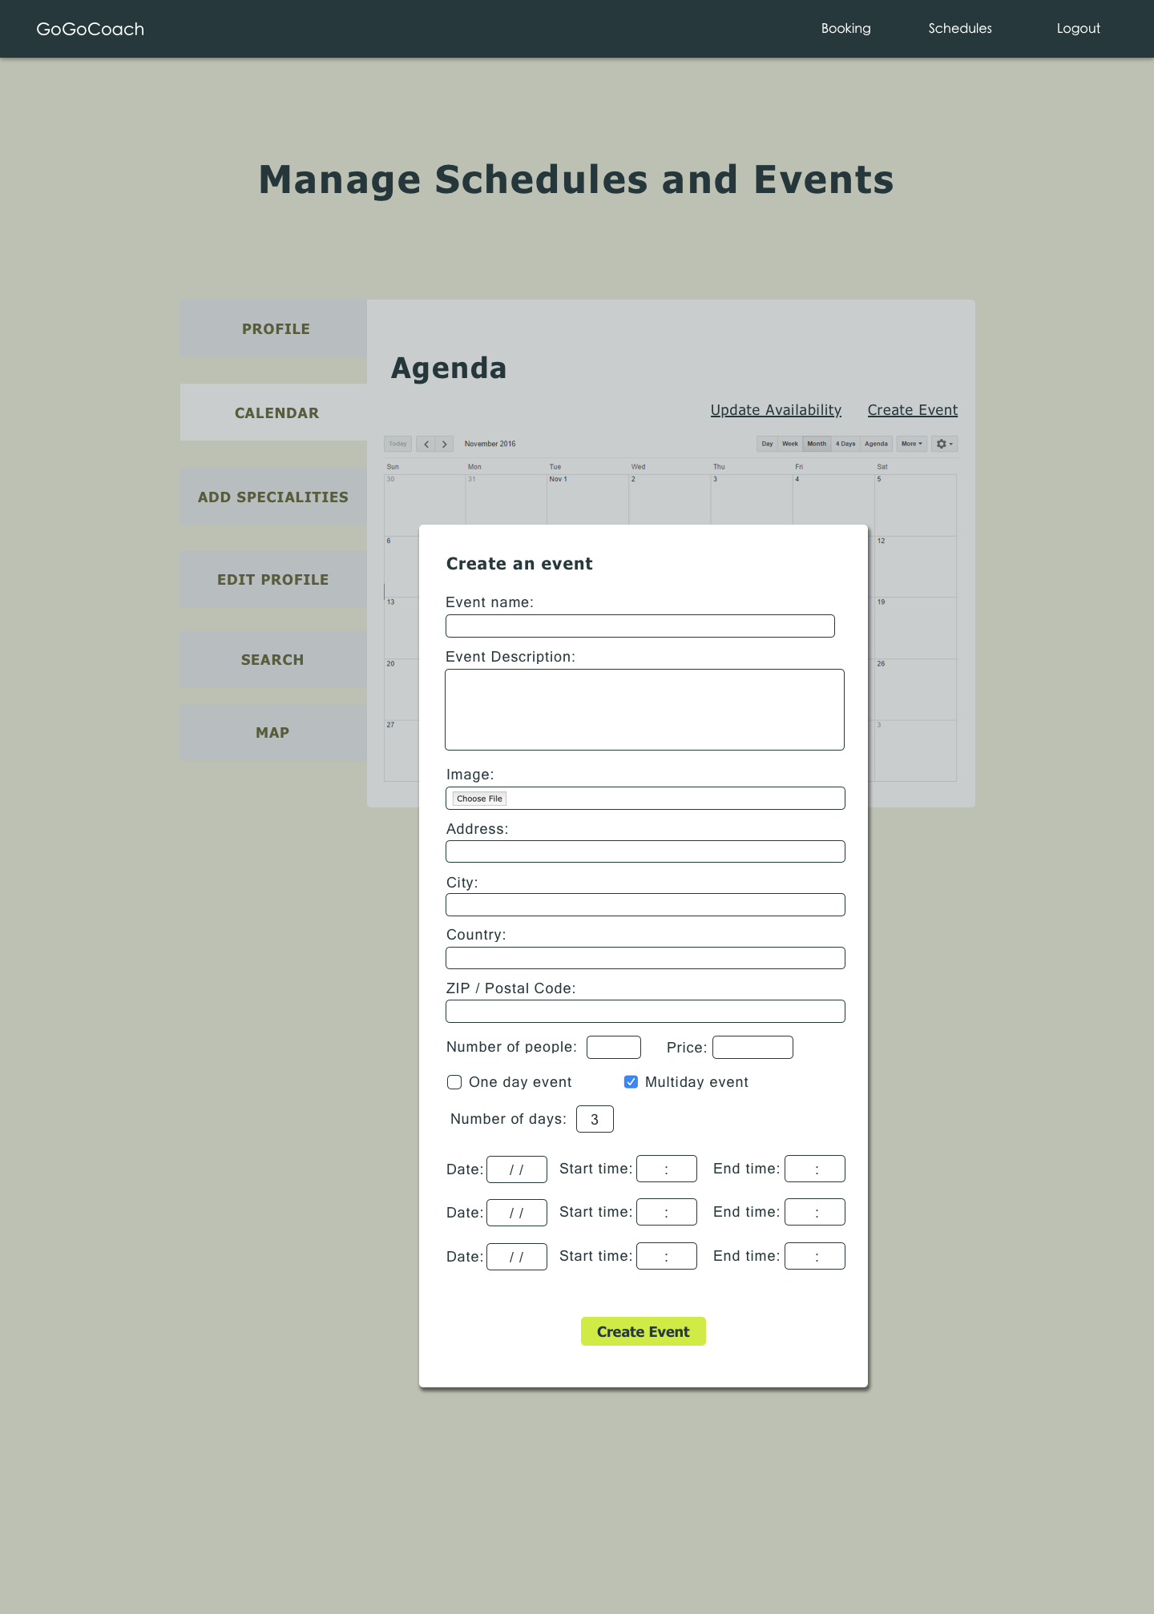

Weekly agenda

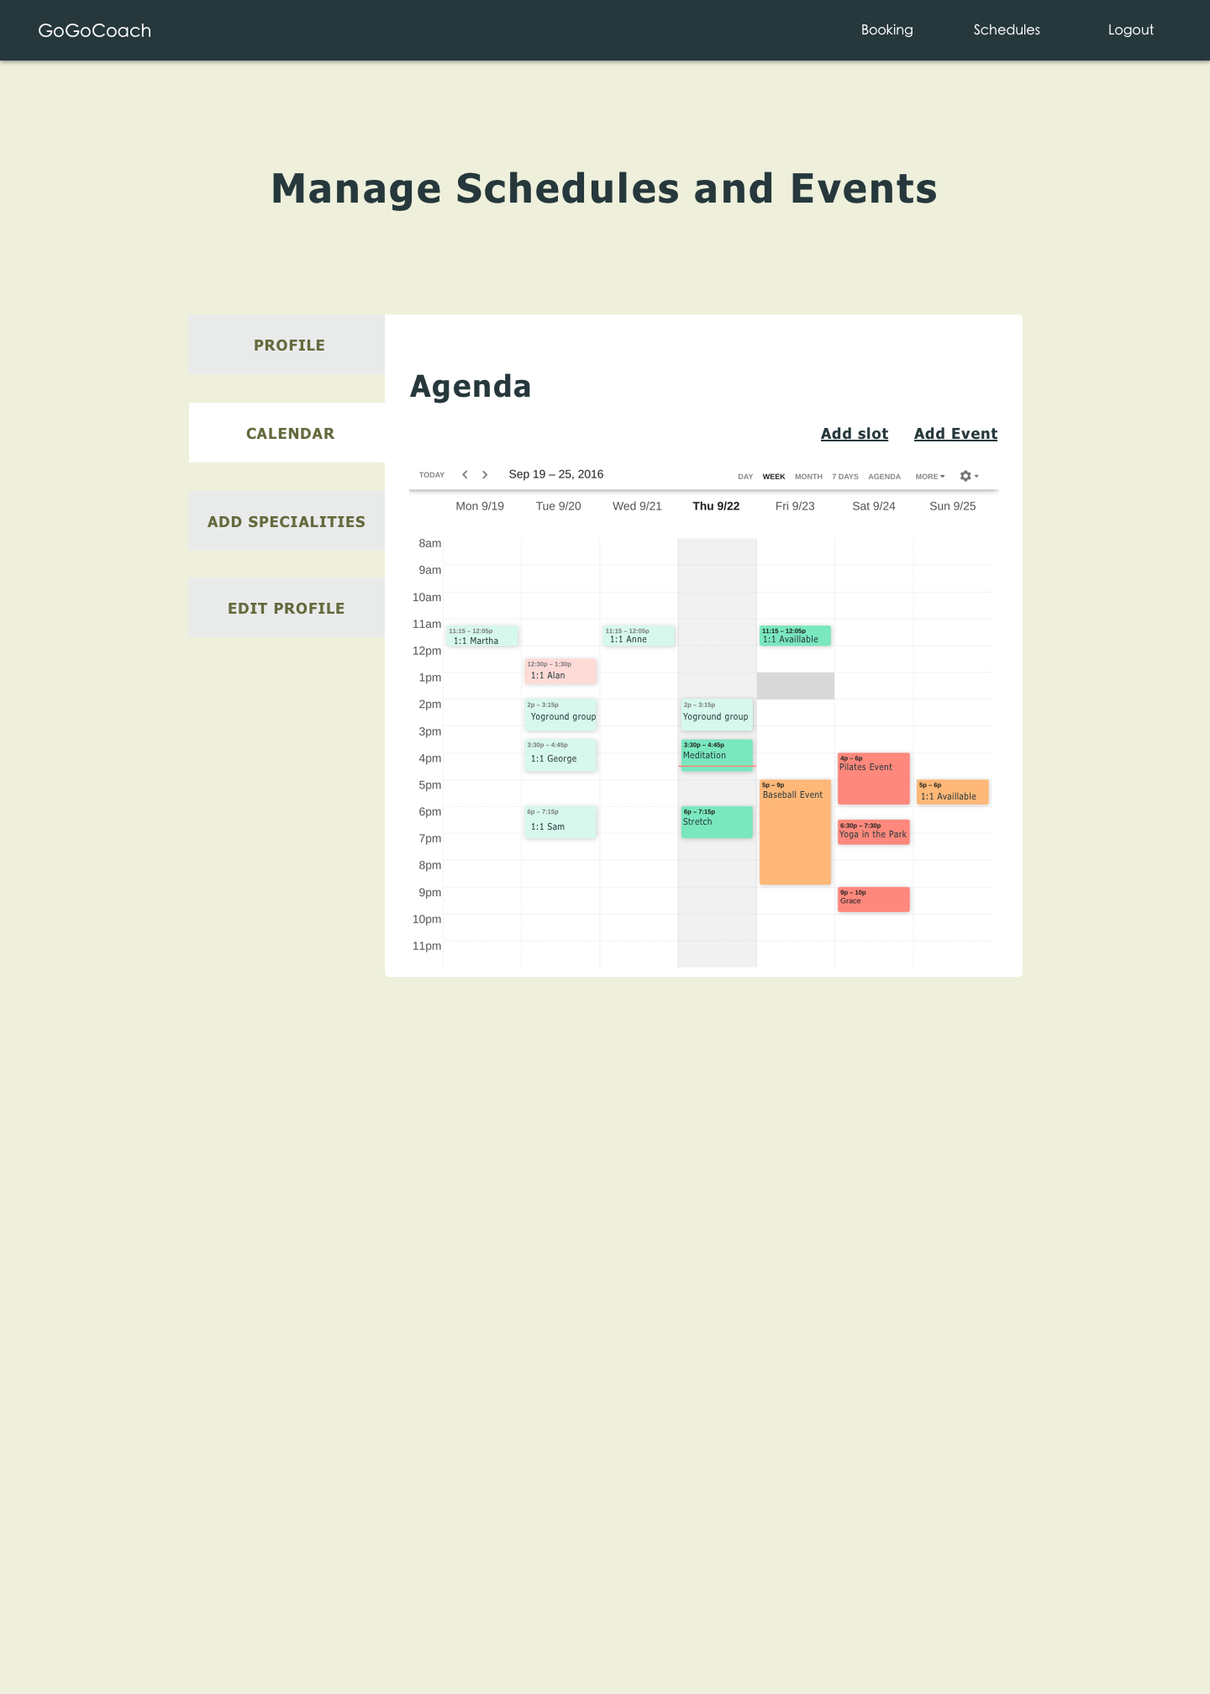

Add availability slots

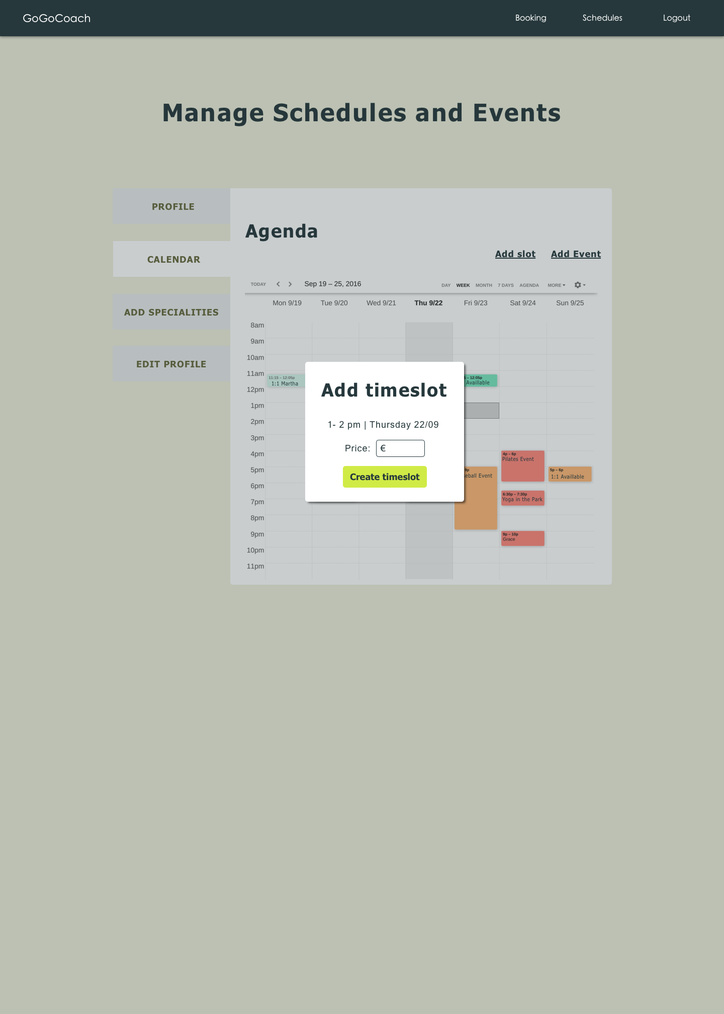

## 5.6 Booking and Payment Module

Users can book an event by selecting the coach and their events from the coach description page and make a payment to confirm the booking.

* Clients select a sports coach from favourites or through search and view availability of slots in any event and book a free slot. Payment is made once the slot is confirmed and waits for final approval from the coach.
* Sports coach can manage booking requests by checking with the payment details. Once the payment is successful, approve the booking request and a confirmation message is sent to the user. If payment unsuccessful, booking requests are rejected to the user.
* Sports coach can get notifications when any client books his event.

### Sequence Diagrams:

* + Client books for coach events

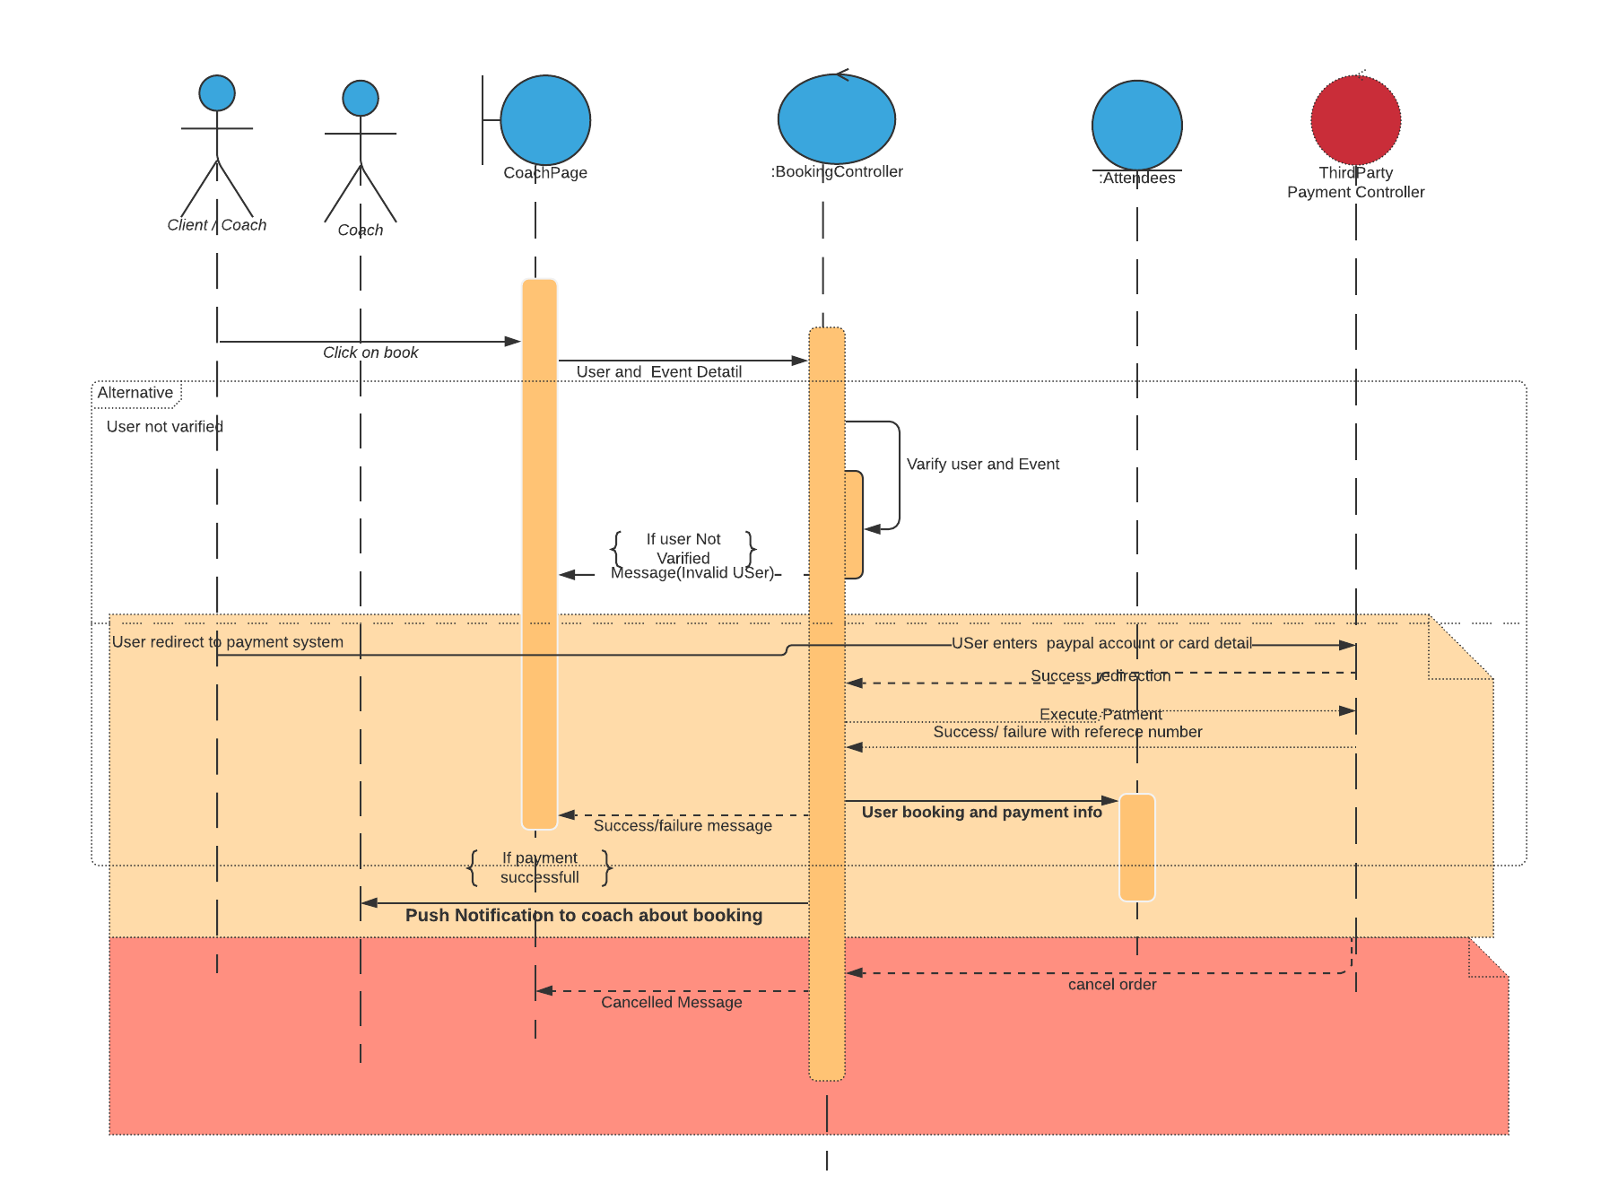

* + Coach accept / Reject Booking

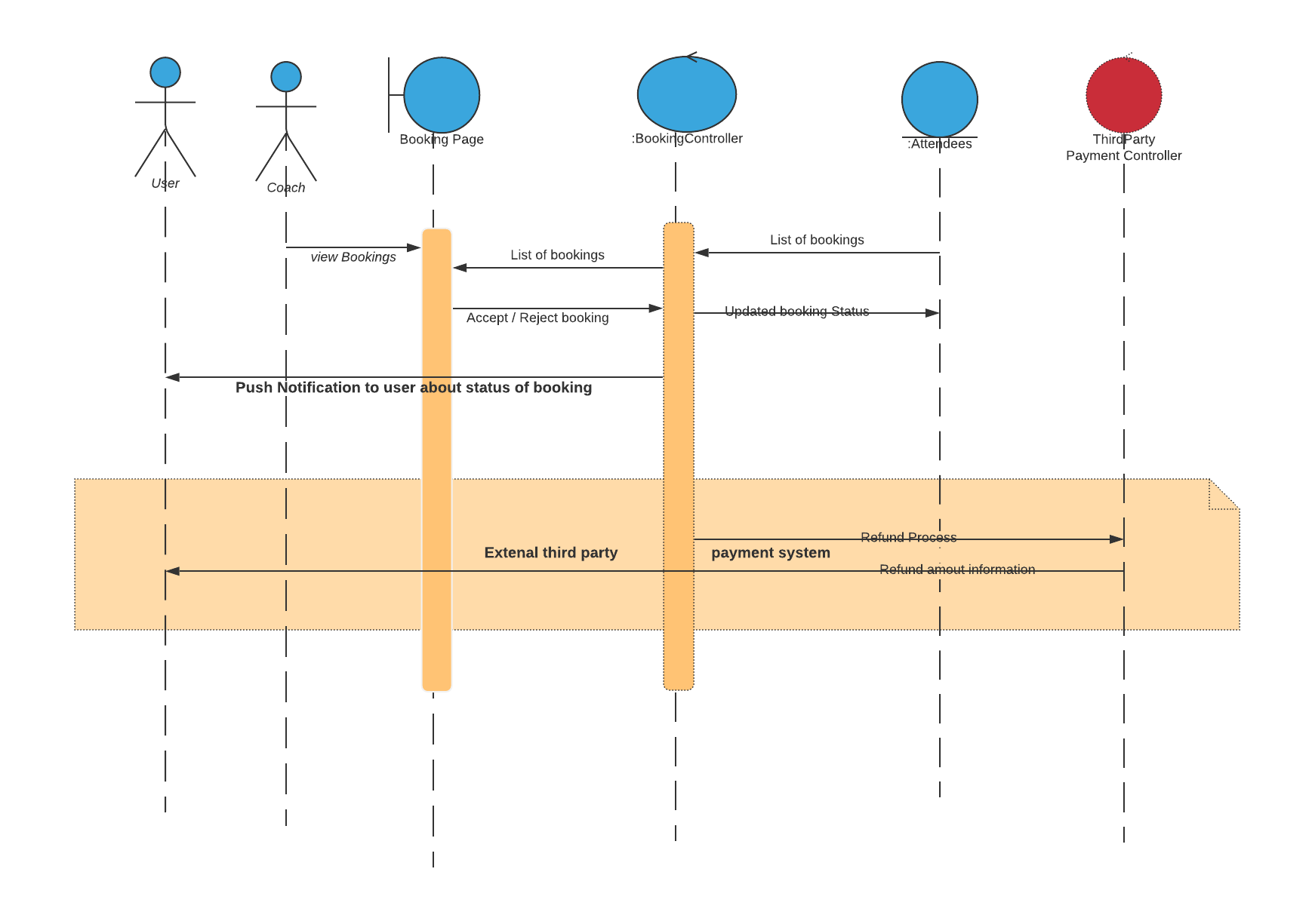

### Mockup Screens:

Mobile view of Coach page

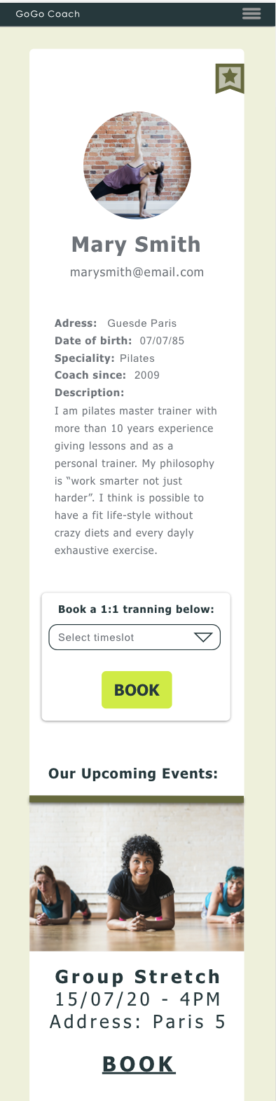

Coach page - Book a slot or Event

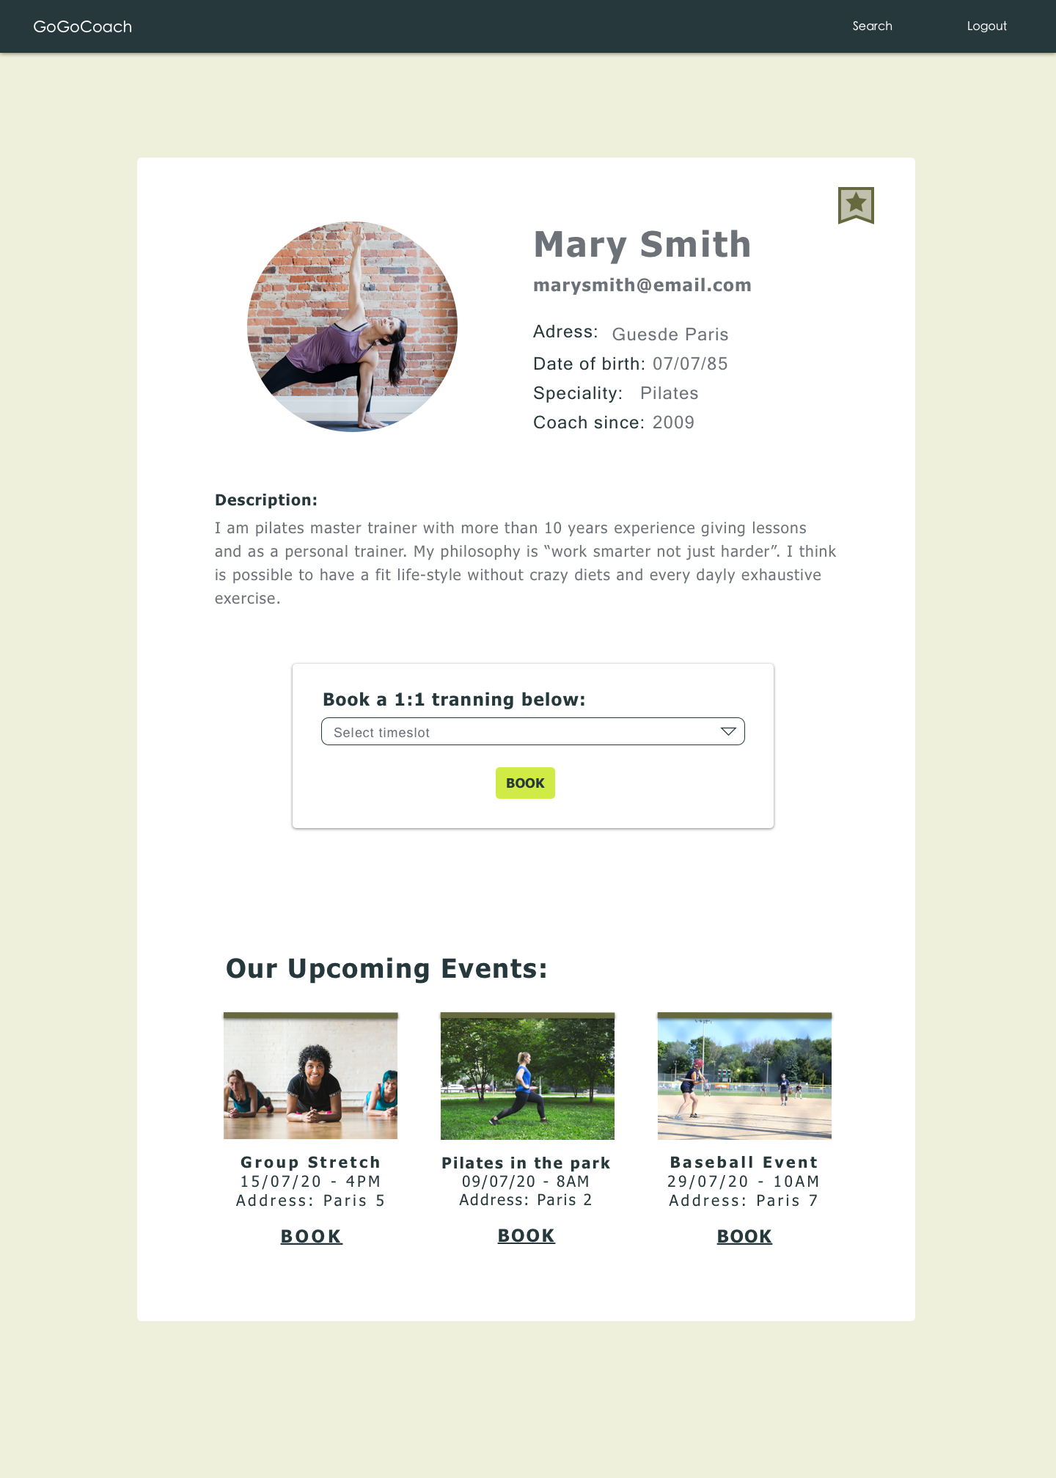

Coach page - Dropdown button

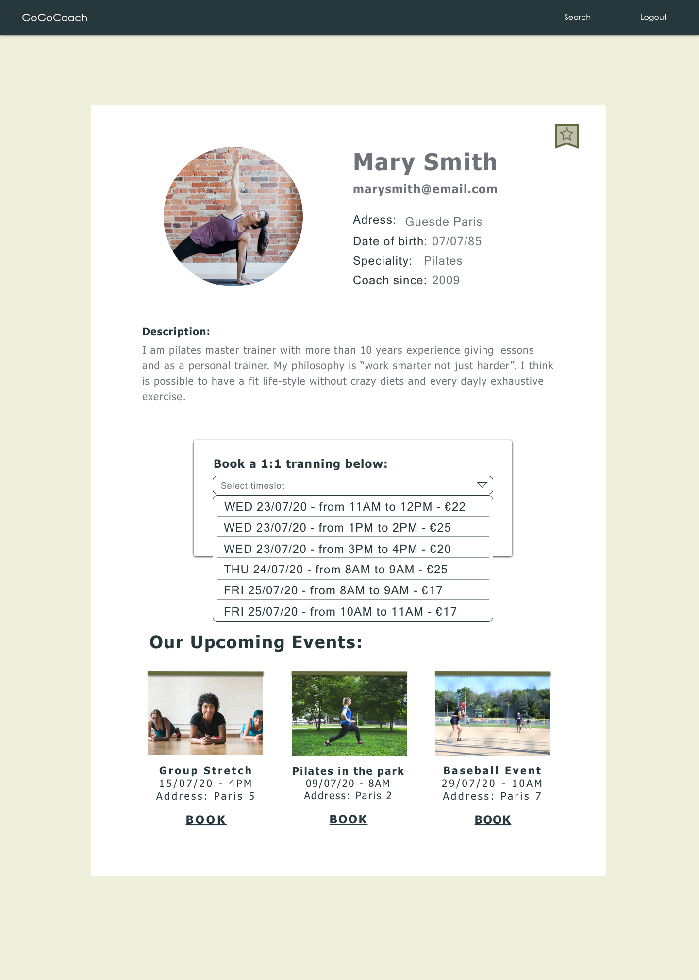

Coach page - Select a slot

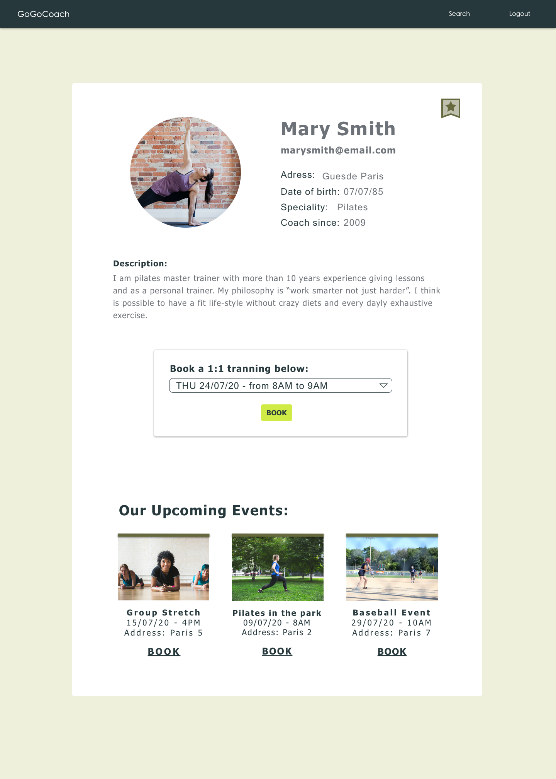

Book an Event

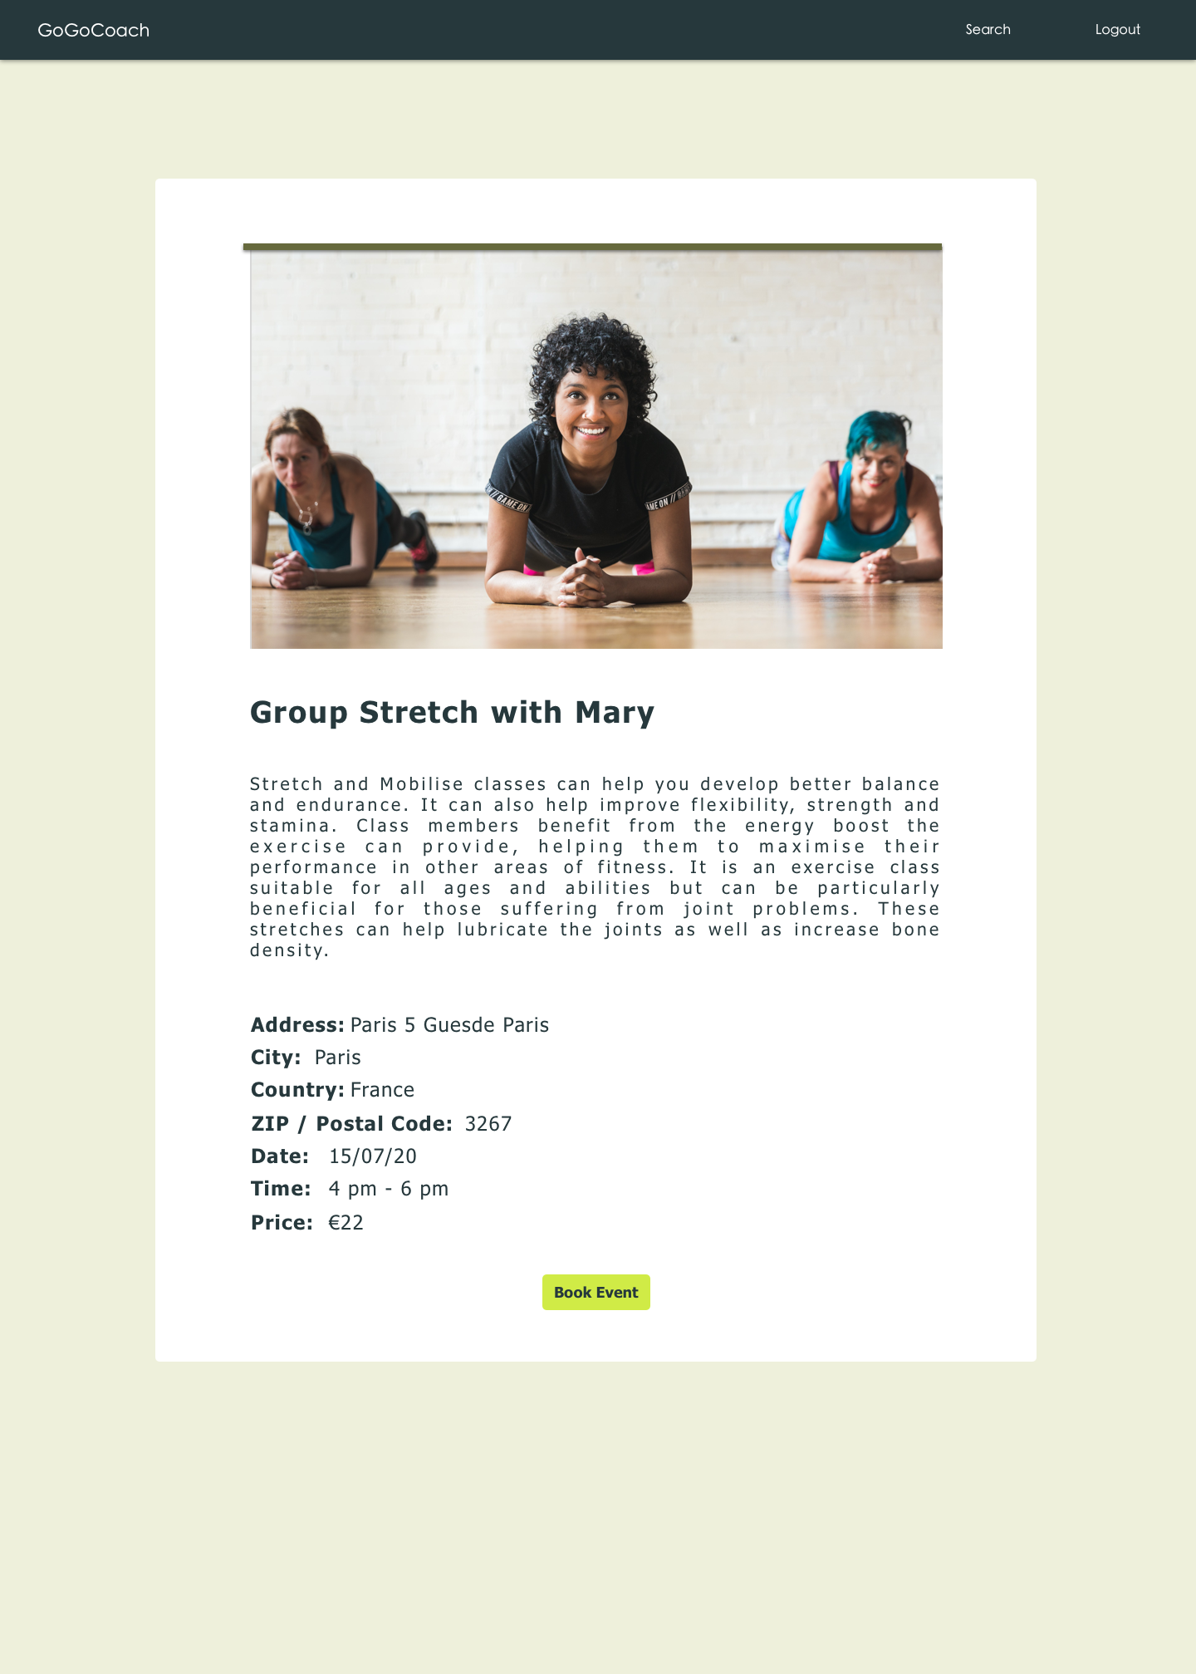

Payment through paypal

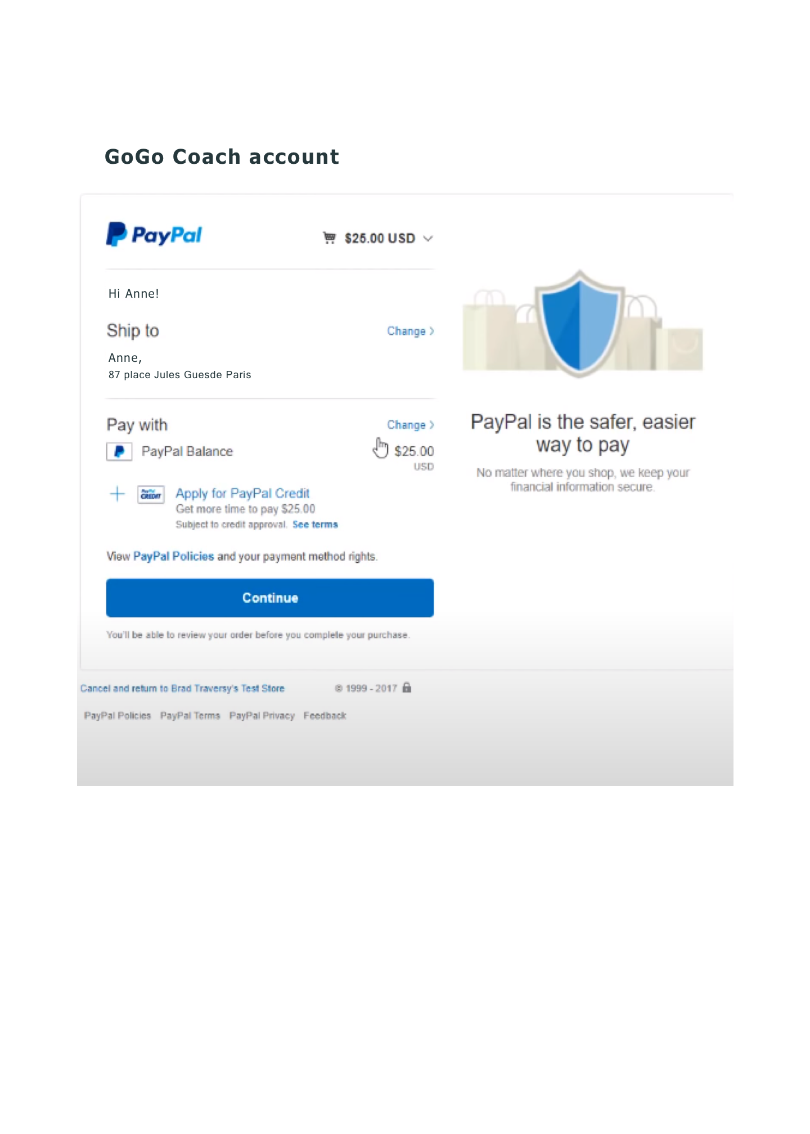

Message of success

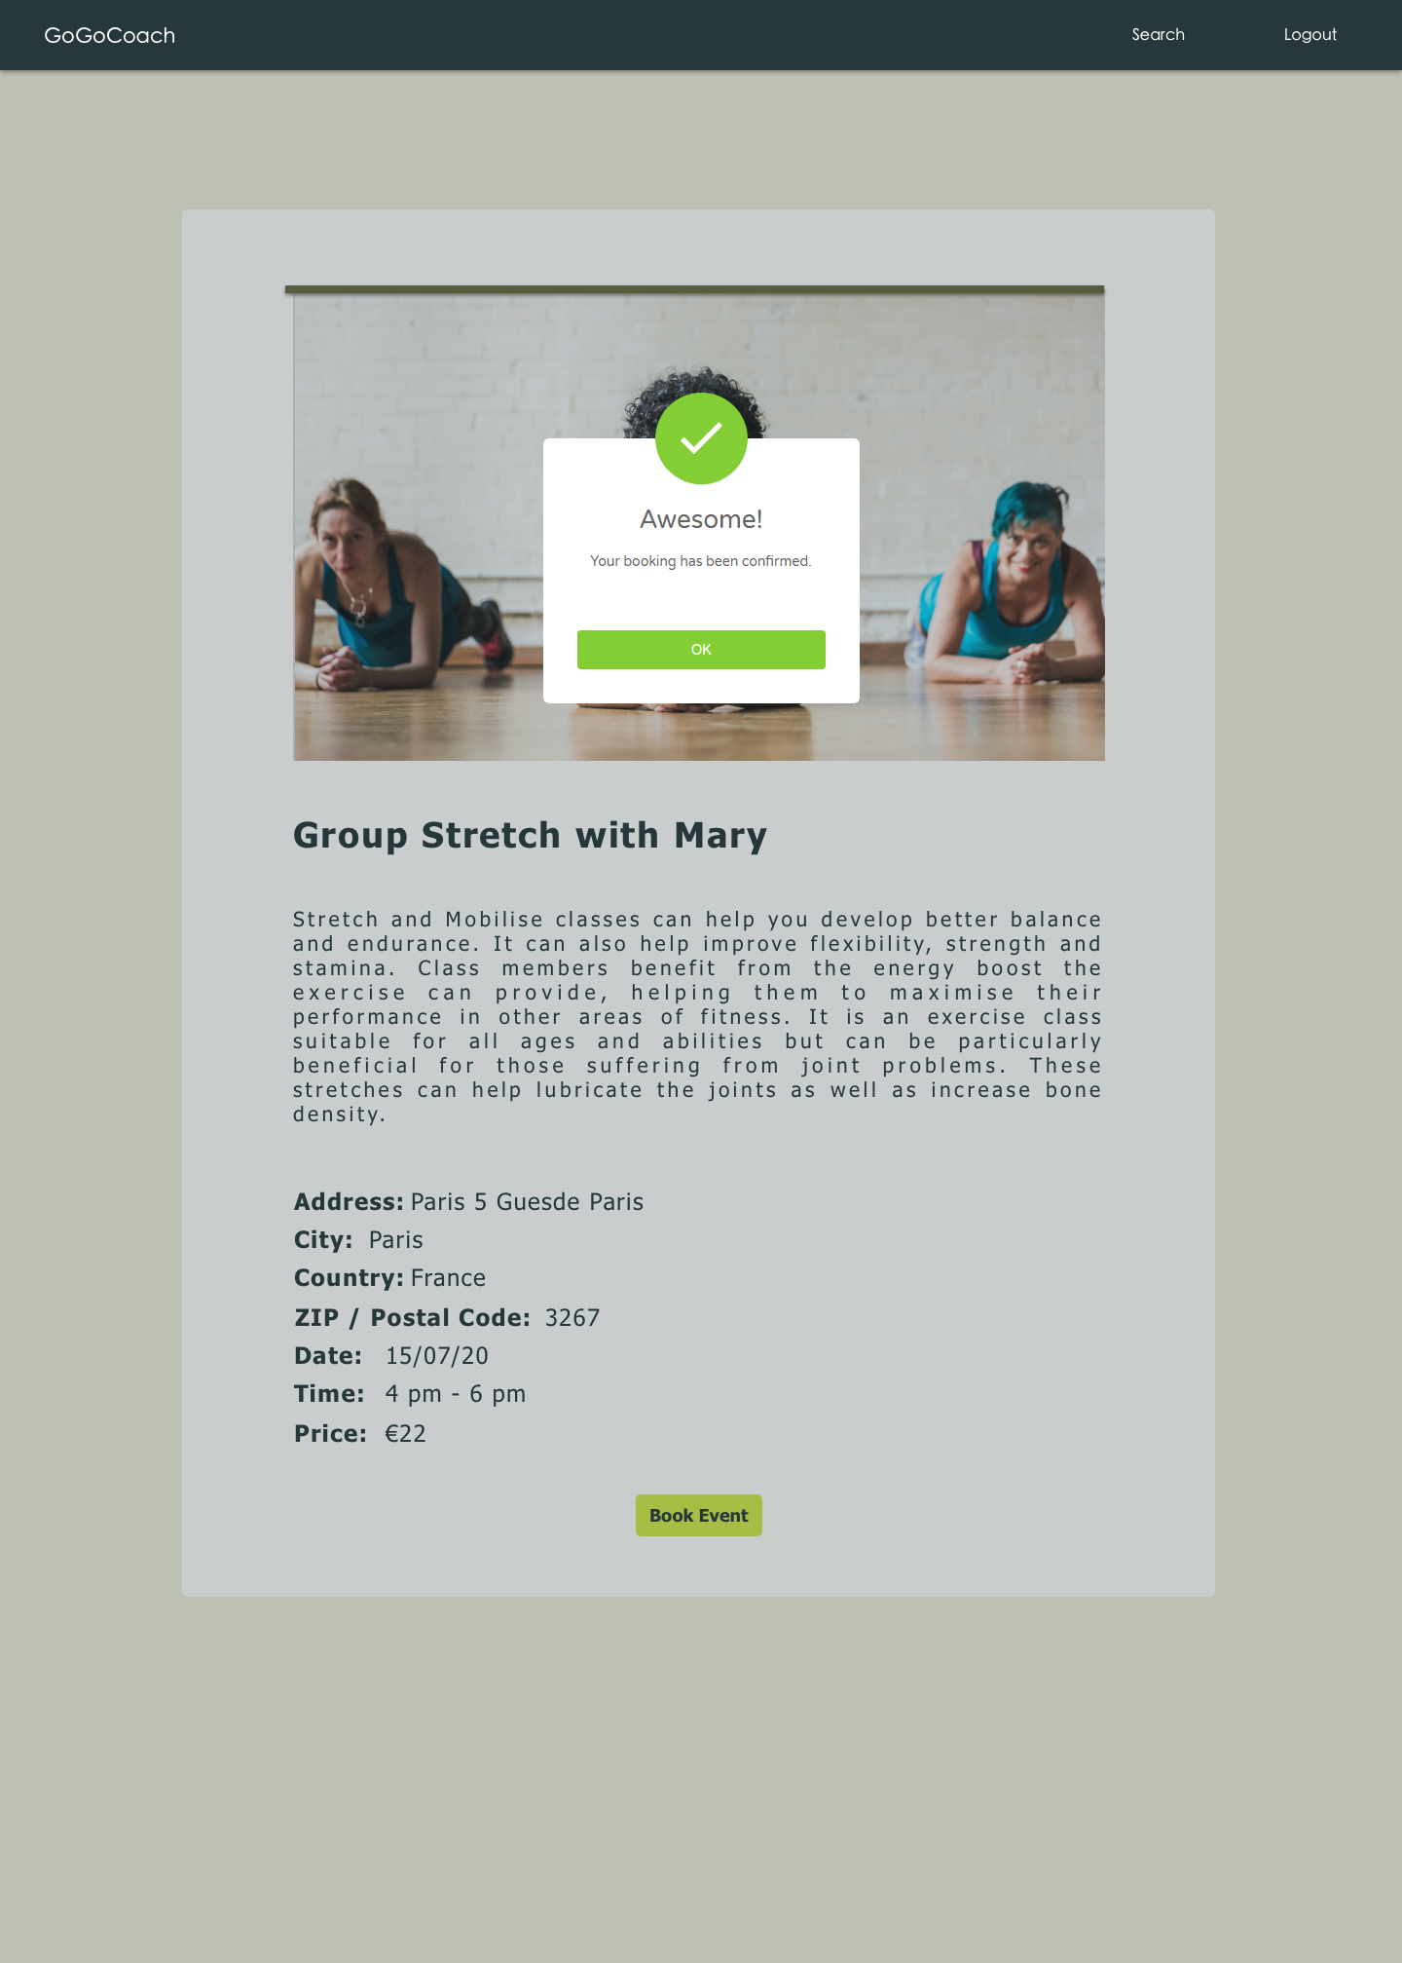

Client profile bookings

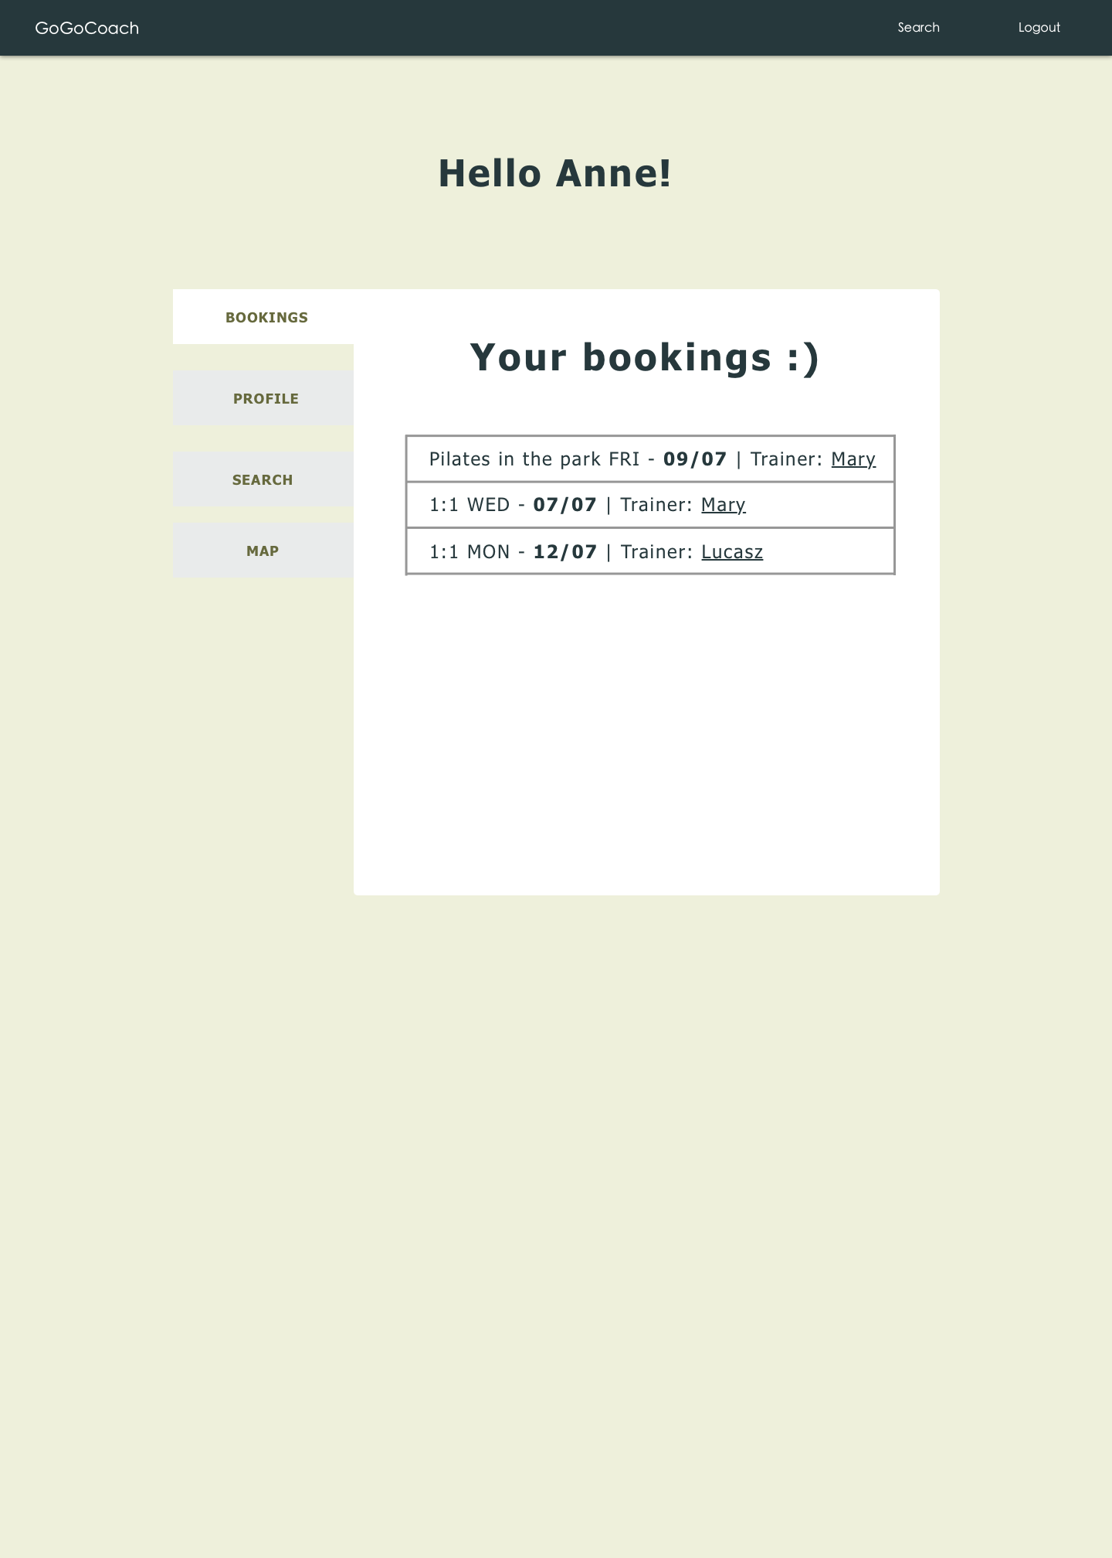

# 6.Application Requirements

## 6.1.1 User Interface:

HTML has been used for developing the user layout for the system.

JavaScript has been used for creating all the validations and client-side scripting functionality.

CSS has been used for designing the web page of the system.

## 6.1.2 Application:

Client On Internet: Web Browser, Operating System (Any)

Web Server: Node JS

Database: MongoDb

Mark-up Language: HTML, CSS

Scripting Language: JavaScript, jQuery

Third-Party payment: Braintree PayPal

push-notification : web-push and service worker